[Rube Goldberg]
[Final Report]

[Amy Downhill]
[Nahar Alotaibi]
[Alivia Tongate]
[Abdulrahman Almutairi]
[Angelo Cencioso]
[Hamad Almerri]

2018-2019
Submitted towards partial fulfillment of the requirements for
Mechanical Engineering Design II
– May 3, 2019



Department of Mechanical Engineering
Northern Arizona University
Flagstaff, AZ 86011

Project Sponsor: Dr. David Trevas
Faculty Advisor: Dr. David Trevas

DISCLAIMER
This report was prepared by students as part of a university course requirement. While considerable effort has been put into the project, it is not the work of licensed engineers and has not undergone the extensive verification that is common in the profession. The information, data, conclusions, and content of this report should not be relied on or utilized without thorough, independent testing and verification. University faculty members may have been associated with this project as advisors, sponsors, or course instructors, but as such they are not responsible for the accuracy of results or conclusion.

DISCLAIMER 2
1 Background 5
1.1 Introduction 5
1.2 Project Description 5
2 Requirements 5
2.1 Customer Requirements 5
2.2 Engineering Requirements 6
2.3 Testing Procedures 8
2.5 House of Quality 8
3 Existing Designs 9
3.1 Design Research 9
3.2 System Level Design 10
3.3 Subsystem Level Designs 10
Scissor Lift 10
Newton’s Cradle 11
Centripetal Force Design 11
Dual Pendulum 12
Roller Jar 13
Bunny Bellow Subsystem Assembly 14
4 Designs Considered 15
Hair Dryer Propelled Sail 15
Punching Arm 16
Newton’s Cradle 17
Centripetal Force Mobile 17
Dual Pendulums 17
Rolling Jar 17
Bunny Bellow 18
Toothbrush Switchblade 18
Gear System 19
Coin Funnel 20
Levitating Ball 21
5 Design Selected 22
5.1 Rationale for Design Selection 22
5.2 Design Description 23
6 Proposed Design 26
7 Implementation 28
7.1 Manufacturing 28
7.2 Design Changes 33
8 Testing 40
9 Conclusions 40
9.1 Contribution to Project Success 40
9.2 Opportunity for Improvement 41
Appendix A 44
Appendix B 48
Appendix C 50
Appendix D 51

1 Background

1.1 Introduction
The Rube Goldberg Machine (RGM) is named after the American cartoonist who originally created the design in his comics. Rube Goldberg machines are deliberately over-designed to perform simple tasks in a complex and entertaining manner. The RGM consists of an assembly of several individual steps. In the machine design, succeeding steps are triggered by the preceding steps, which combine to eventually complete the designated task. This project is sponsored by Dr. Trevas and Northern Arizona University. Upon completion, the project will benefit each team member by granting experience with the completion of an employment level project. The project will also allow the team to hone an understanding of physics and kinematics to ensure each step of the machine functions as intended.

1.2 Project Description
The goal of this project was to create a sequence of simple steps that combine to complete a simple task. Specific parameters for the device were determined by the team’s former competition sponsor, Purdue, and the team’s client, Dr. Trevas. The competition rules state the assembly must have at least 30 steps, a 3 minute maximum run time, an area restriction of 12 feet by 12 feet, and a maximum assembly volume of 400 ft³. While the team is no longer participating in this competition, the team is still operating in accordance with these project parameters. The end goal of the machine is to put toothpaste on a toothbrush. For the client’s customer requirements, the steps utilized in the chain reaction machine must be reliable, durable, self-resetting, and must include some form of a human integrated step. The final design must also be aesthetically inspired by Rube Goldberg’s cartoons, easy to follow, and entertaining.

2 Requirements

2.1 Customer Requirements
The customer needs from the client and sponsor discussed in section 1.2 were compiled in Table 1. The importance of each customer requirement was ranked on a scale from 1 to 5, with 5 being the most important and 1 being the least important.

Table 1: Customer Requirements and Relative Weighting
Customer Requirement | Relative Weighting
Cartoon Inspired | 2
Human Integration | 5
Self-Resetting | 5
Easy to Follow | 4
Entertaining | 4
3 Minute Maximum | 5
30 Step Minimum | 5
Reliability | 5
Durability | 3
Animatronic Integration | 2
Collapsable Assembly | 4

The team determined that human integration, self-resetting, 3 minute maximum, 30 step minimum, and reliability were the most important customer requirements. The next most important customer requirements were that the designs must be easy to follow, entertaining, and collapsable. The lowest ranked customer requirements were the aesthetic requirements, since they do not impact device functionality. The team has worked to make the appearance of the designs adhere to the project parameters, but has focused more heavily on the functionality of the device. The customer requirements were used to create the project’s engineering requirements.

2.2 Engineering Requirements
The engineering requirements for the project were developed to give quantitative measures to meet the customer requirements. These requirements are listed in Table 2.

Table 2: Engineering requirements (ERs)
Engineering requirement | Target values
Age of Components (years) | 30
Automated Steps (yes/no) | Yes
Volume of Assembly (ft³) | 400
Volume of Step (ft³) | 14
Time per Step (s) | 5
Run Time (s) | 180
Number of steps (steps) | 30
Strength (PSI) | 3000
Young’s Modulus (PSI) | 100000
Precision (in) | 0.5
Accuracy (in) | 0.5
Aesthetically Pleasing (yes/no) | Yes
Visibility Percentage (%) | 80
Cost ($) | 1500

To address the cartoon inspiration and animal integration requirements, the team decided to prioritize including older components, which are more likely to resemble the classic Rube Goldberg cartoons. Since each step needed to be self-resetting, the team has worked to make sure each step was automated. The customer requirements for volume directly give the engineering requirements since they are equal. The time per step, runtime for assembly and the number of steps for the assembly were given by the time limit and step minimum customer requirement. The strength and young’s modulus influence the assembly’s durability. The target values for these requirements are different for every step, so the target value changed for each. The precision and accuracy engineering requirements influenced the reliability of the device. The visibility percentage and aesthetically pleasing requirements addressed the easy to follow and entertaining customer requirements. The cost also impacted each customer requirement.

2.3 Testing Procedures
The testing procedures that the team implemented was prototype testing. The team has prototyped a number of individual steps that are now a part of the final assembly of the machine. Each prototype was evaluated for functionality, reliability, and self-resetting capability. If the prototypes were viable in each category, the team created full scale models of the step for the final design. However, if the design was not functional, reliable, or self-resetting, the team worked to adjust the prototype to meet more of the project parameters.

Looking forward, the team will continue to build and test final designs of the steps. The team will test the assembly to make sure each step completes its action, actuates following steps, and self-resets through subsequent runs.

2.5 House of Quality
The house of quality was used to determine which engineering requirements had the greatest impact on meeting the customer needs of the project. The customer needs, relative project weighting, engineering requirements and target values listed in tables 1 and 2 were used in the house of quality. Each engineering requirement was rated against each customer requirement and assigned a value of 0, 1, 3, or 9 depending on how much the engineering requirement impacted each customer requirement. A value of 0 symbolizes no correlation between the engineering requirement and the customer requirement, 1 symbolizes a slight correlation, 3 symbolizes a moderate correlation, and 9 symbolizes a large correlation. The absolute technical importance was calculated by multiplying the engineering requirement score for each customer requirement by the customer requirements relative weighting, and summed the values. The relative weighting was calculated by dividing the calculated absolute technical importance score by the maximum amount of points available. Engineering requirements with the largest absolute and relative importance scores had the greatest impact on the largest number of customer requirements, making them the biggest focus of design.

Table 3: House of Quality
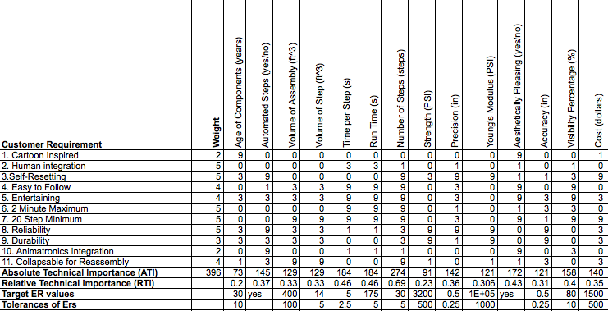

The most important engineering requirements were found to be automated steps, volume of assembly, time per step, run time, number of steps, and visibility percentage, because they ranked highest in absolute and relative technical importance.

3 Existing Designs

3.1 Design Research
Several designs were researched in the initial design phases. One of the benchmark designs was OK GO’s Rube Goldberg machine featured in their music video. It was created to move in time to the music, and had a four minutes runtime [1]. A design this large in scale was not feasible considering the specific project parameters and time limits, however we have tried to incorporate some of the design features. The major takeaways from OK GO’s design were how easy it was to follow, its creative steps and its ability to keep the viewer engaged. The second researched design, Purdue’s PSPE entry, won last year’s Rube Goldberg competition [2]. The design was very intricate and entertaining. There were no pauses when the device was actually in motion. However, it was hard to follow over its entire motion because some of the steps seemed to occur instantaneously. This was undesirable because one of the focuses of this project was that the machine must be easy to follow. Finally, NAU’s design from last year was taken into account [3]. Their design was easy to follow, however, it was not very aesthetically pleasing. Combining all the desirable traits from the benchmarking created solid machine components for this years chain reaction machine.

3.2 System Level Design
In OK GO’s machine there were well over 30 steps. It began by simply using an old toy truck to knock over dominos. This was an obvious transfer of kinetic energy by domino to domino and when the last domino fell it’s connected to a string that pulls out a stopper holding a car on a ramp back. This allowed for the potential energy of the car in the ramp to be transferred into kinetic energy and as it rolled down the ramp it continued onto the next ramp. This section of the overall system informed the group that transfers of energy were going to be the main focus point of the project.

3.3 Subsystem Level Designs
The chain reaction machine is comprised of a combination of subsystem tasks. Each step in the chain reaction machine represents a subsystem level design. The machine combines a minimum of 30 subsystem level designs to complete the final task of placing toothpaste on a toothbrush.

Scissor Lift
One of the subsystem tasks that the group has incorporated into the chain reaction machine was a scissor lift design. As shown in figures 3 and 4, the scissor lift can expand vertically by contracting laterally, as well as contract vertically by expanding laterally.

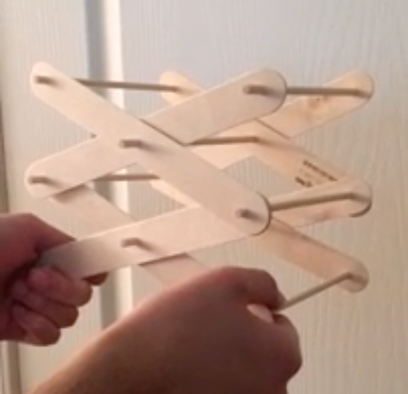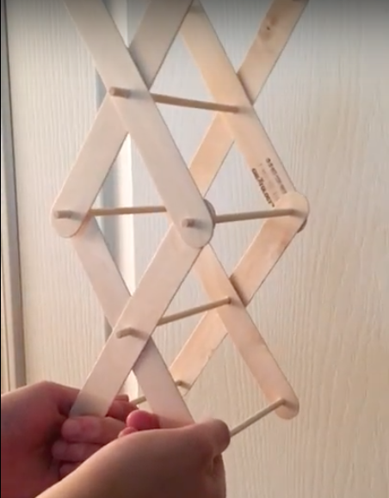
Figure 3: Vertically Contracted Scissor Lift Figure 4: Vertically Expanded Scissor Lift

The scissor lift is completely automated. A previous step actuates the scissor lift motor, which in turn works to expand the lift vertically. After reaching a certain vertical displacement, the scissor lift will make contact with and start the next step. After completing the action, the motor returns the extended lift to its original position.

This step was able to address multiple project parameters. Since the lift is automated, it functions and resets without intervention, making the step self-resetting and reliable. The design is also cartoonesque because a boxing glove will be affixed to the top of the lift to resemble the scissor lift designs used in traditional Rube Goldberg machines. The design is easy to follow and entertaining because the scissor lift action takes a couple seconds to complete its action, and its volume makes it easily visible.

Newton’s Cradle
Newton’s cradle is a subsystem task that has been implemented into the chain reaction machine. The cradle, shown in figure 5, serves as physical contact between the preceding and following steps.


Figure 5: Newton’s Cradle [4]

A previous step makes physical contact with the cradle from one side, transferring the energy from the initial contact to the other side of the cradle, starting the next step.

The Newton’s cradle does not change position during its run time, so it is both resettable and reliable. The cradle is easy to follow because it serves serves as the connection between the previous and following steps. The design is also aesthetically pleasing, making it entertaining.

Centripetal Force Design
The centripetal force design uses centripetal force to start the following step. A motor is actuated by a previous step, which rotates a wheel with two weights attached to it. As the rotational speed increases, the weights lift outwards, which eventually comes into contact with something which starts the following step. A sketch of the step is shown in figure 6.
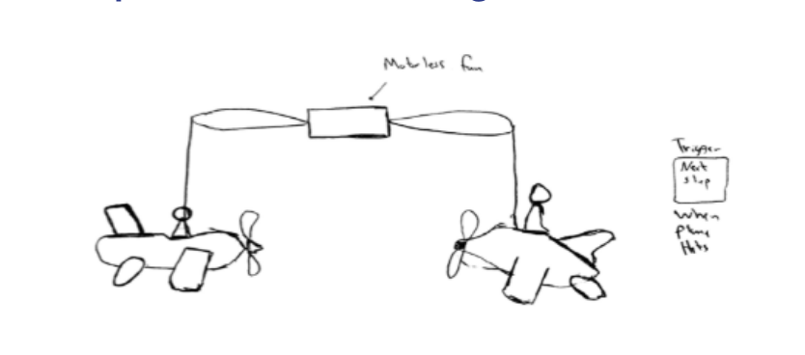
Figure 6: Centripetal Force Step

Since the step is completely automated, it is reliable. It is also self-resetting because the weights will return to their initial position relative to the wheel after the rotation of the wheel stops. The step is easy to follow and entertaining, because it has a large enough volume to be easily visible, and should take a couple seconds to complete its action.

Dual Pendulum
The dual pendulum step uses harmonics to start the following step. There are two pendulums connected towards the center that are equally spaced, as shown in figure 7. One of the pendulums is struck by a previous step, initiating the its motion and energy. Since the pendulums are connected by a common wire, the first pendulum moves back and forth without affecting the other pendulum. However, within a couple back and forth motions, the second pendulum will start to take the first pendulum’s energy and the second pendulum then moves back and forth with as much energy as the first pendulum. They continue the transfer of energy until friction slows the motion of the weights to a complete stop. The resulting motion of the second pendulum is enough to trigger the following step.

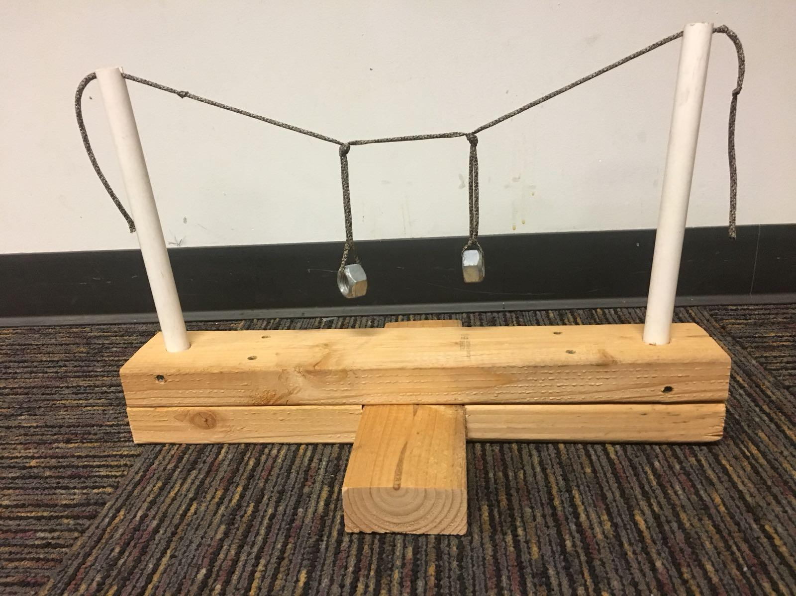
Figure 7: Dual Pendulum Assembly

The design is reliable and self-resetting because both pendulums return to their initial starting positions after the pendulums have lost all of their momentum. The step is also easy to follow, reliable and entertaining because it has a large enough volume to easily view, and takes a couple seconds to complete its task.

Roller Jar
The roller jar uses elastic energy to start the next step. On the inside of a jar, there is a weight that is affixed to the center of a jar by rubber bands. As the jar is rolled in one direction, the weight does not rotate with the jar, causing the rubber bands to rotate, increasing the tension in the bands. After, the bands release their elastic energy from the twisting, causing the jar to jettison in the opposite direction. A previous step moves the jar to increase its elastic energy, then the resulting rolling action starts the next step. A prototype of the jar is shown in Figure 8.

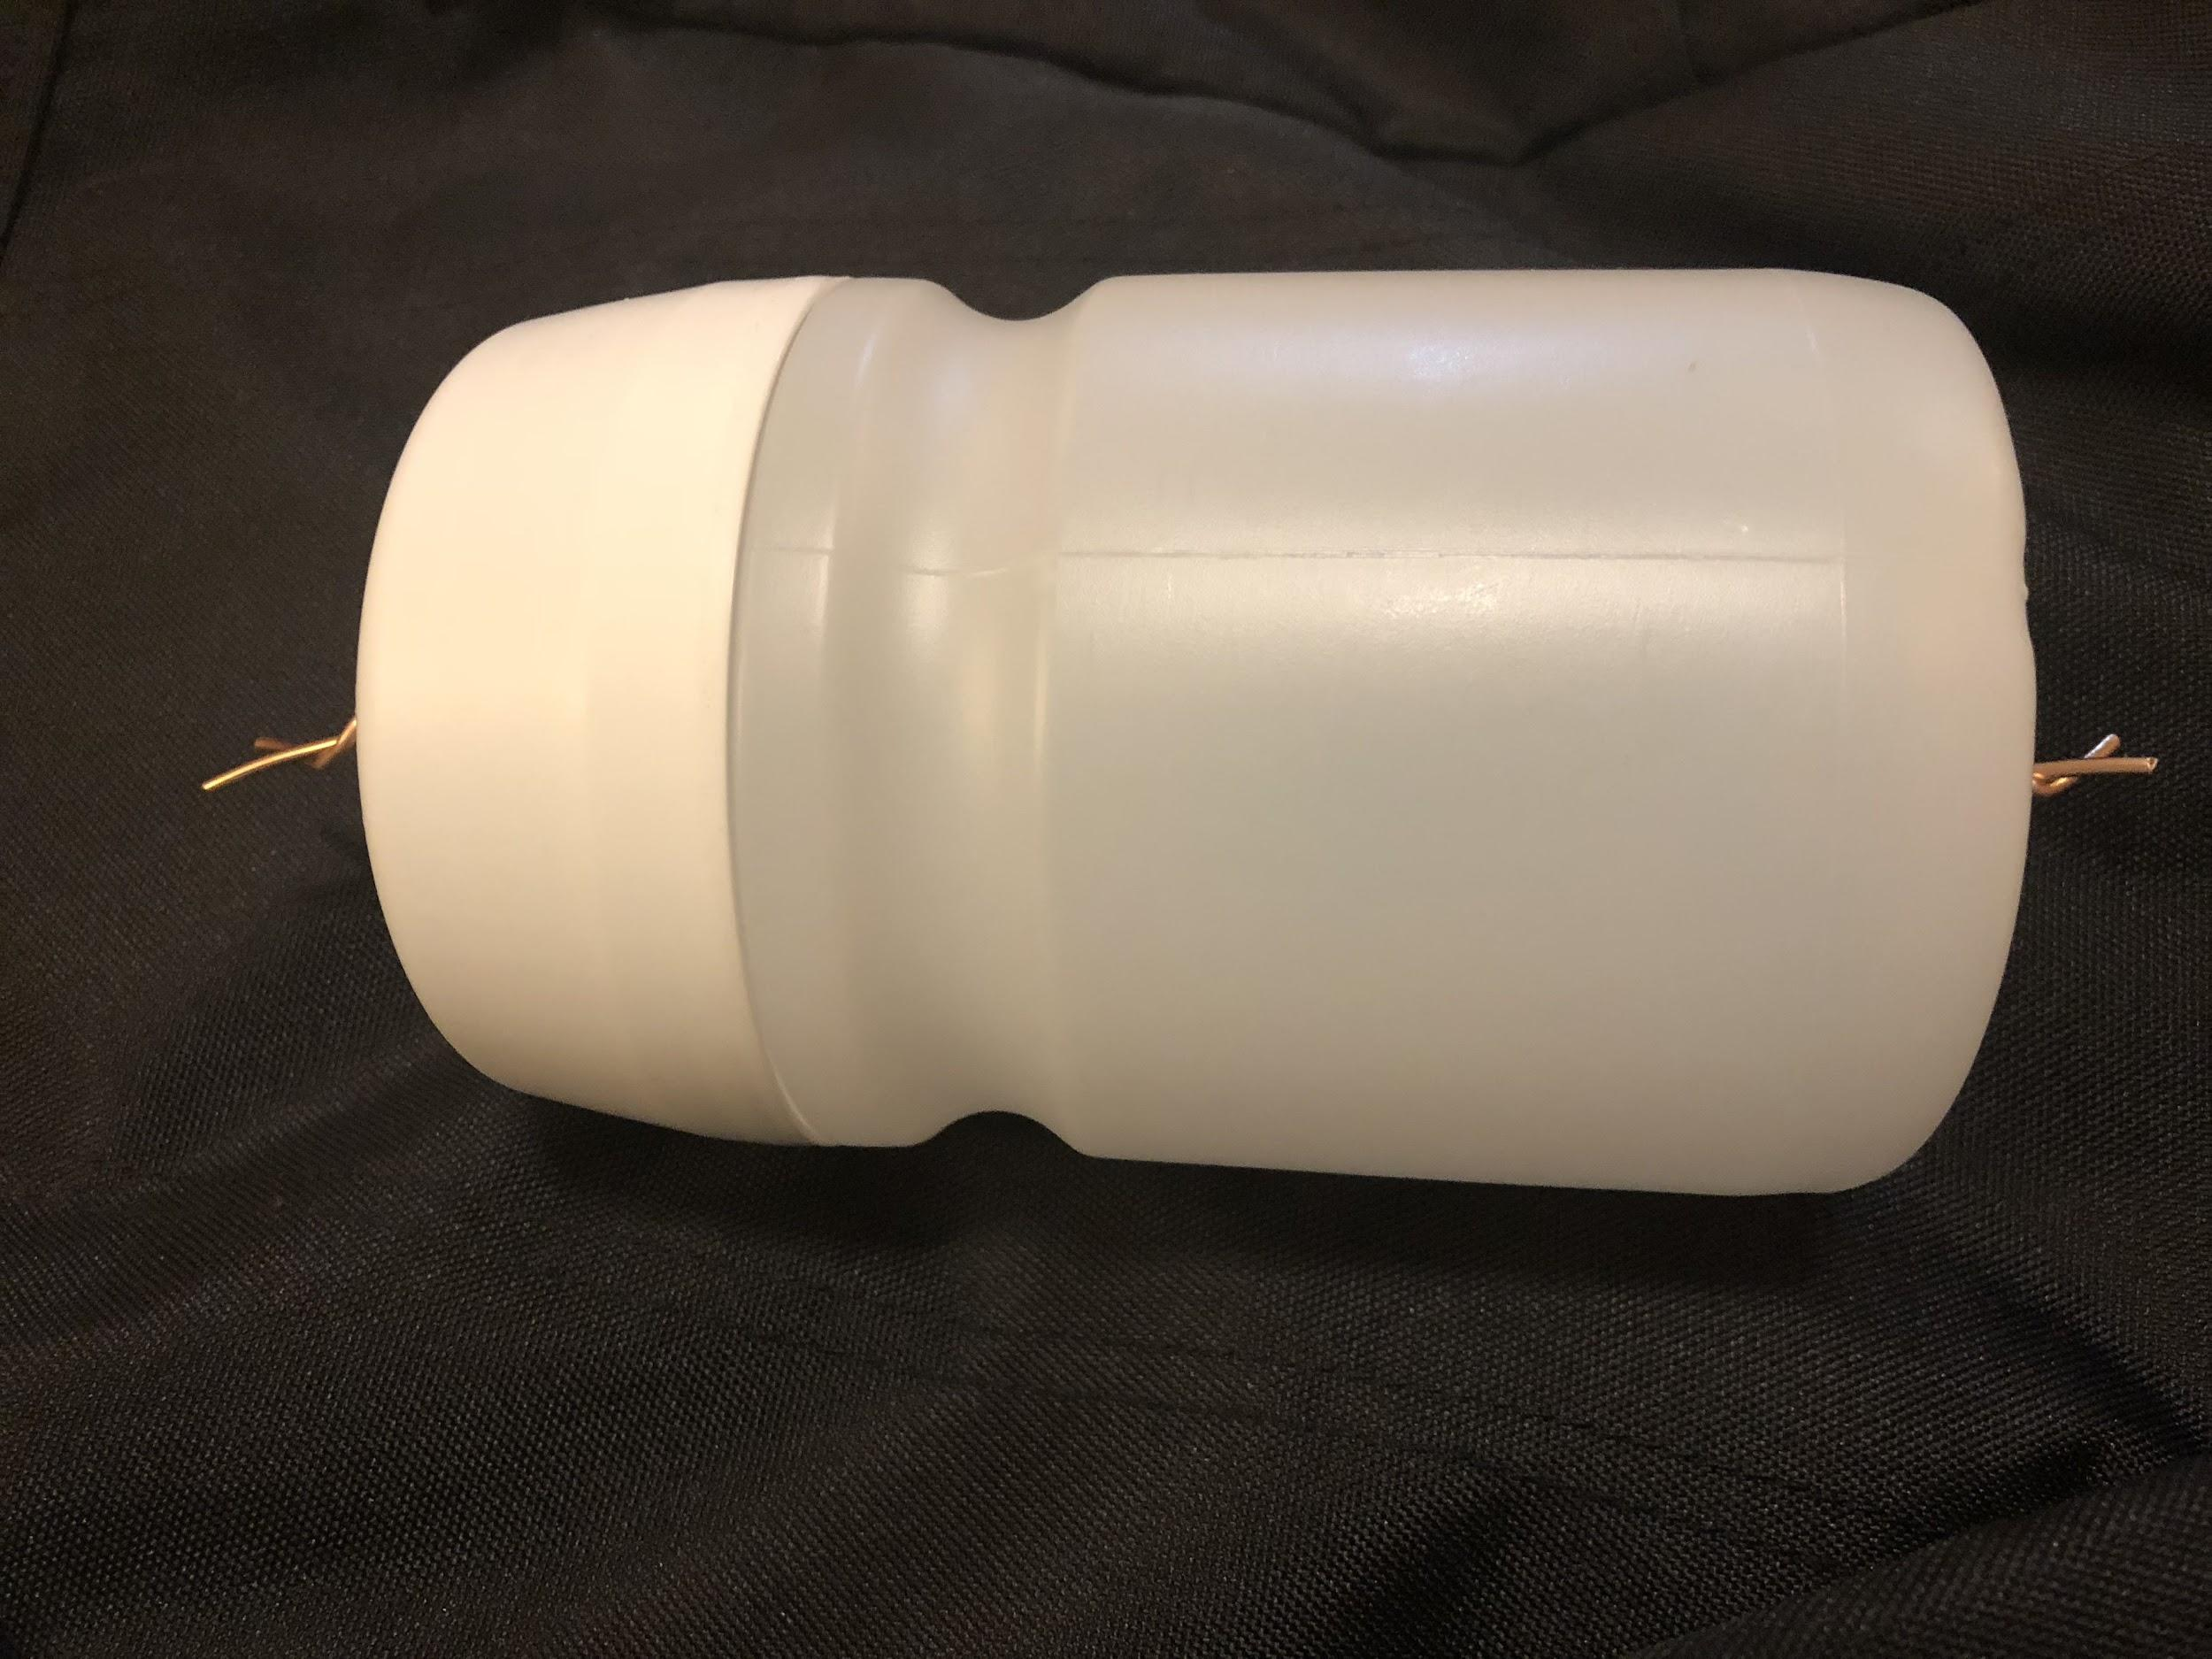
Figure 8: Roller Jar Prototype

The roller jar is resettable because the rubber bands will return to their initial radial position and energy will be conserved, however, the team is working to find a way to return the jar to its original starting position. The step is easy to follow and entertaining because the roller has a large enough volume to easily view the step, and it takes a couple seconds for the jar to complete its rolling action.

Bunny Bellow Subsystem Assembly
The bunny bellow task incorporates multiple subsystem steps into its assembly. The first step of the subsystem assembly involves an inanimate bunny being dropped off a ledge. The bunny’s potential energy at its original position is converted to kinetic energy as it descends towards a bellow, which is compressed on impact. The compression forces air out of the bellow, which makes contact and spins a spool wheel. This spinning action begins the following step by making contact with a switch. The bunny will also be attached to a tether to return it to its initial ledge position. The progression of the steps is shown in Figure 9.

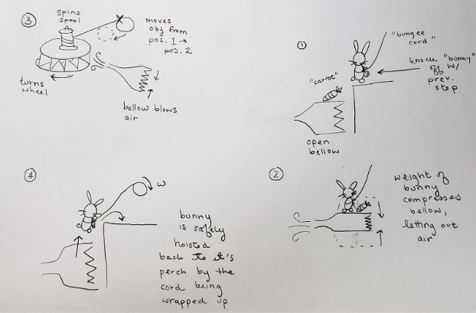
Figure 9: Bunny Bellow Subsystem Assembly

Each of the components of the subsystem assembly will be self-resetting. The bellow fills up with air automatically after it is compressed, and the spool rotates back to its original radial position after the velocity of the air from the bellow is zero. The bunny will be returned to its initial position by using a motor to pull back the tether attached to the bunny. The assembly is also easy to follow and entertaining, because the steps volume is large enough to be easily visible, and the steps take several seconds to complete. The design is also animal inspired and cartoonesque, because bellows were used in the traditional Rube Goldberg devices, and the bunny serves as the weight for the bellow.

4 Designs Considered
When the team began the selection process, we came up with a total of 33 ideas for steps in the chain reaction machine. These ranged from simple transfers of energy to complex integrated steps meshed together. The challenge was to select the designs that fulfilled all engineering and customer requirements.

Hair Dryer Propelled Sail
A single design was chosen as the datum for comparing and judging the rest of our design; a hair dryer propelled sail. Figure 10 shows the sketch that was cartoonish, could be made self-resetting, was easy to follow, entertaining, quick to run, reliable and durable. A disadvantage of this specific design is that it possibly be too bulky to travel with. The client, Dr. Trevas, also informed the team that this design was reminiscent of a previous team’s design. With that in mind, this design will likely not be integrated into the final chain reaction machine. However, it is still a good datum because it had been chosen by another team of engineers as a successful step in their own RGM.

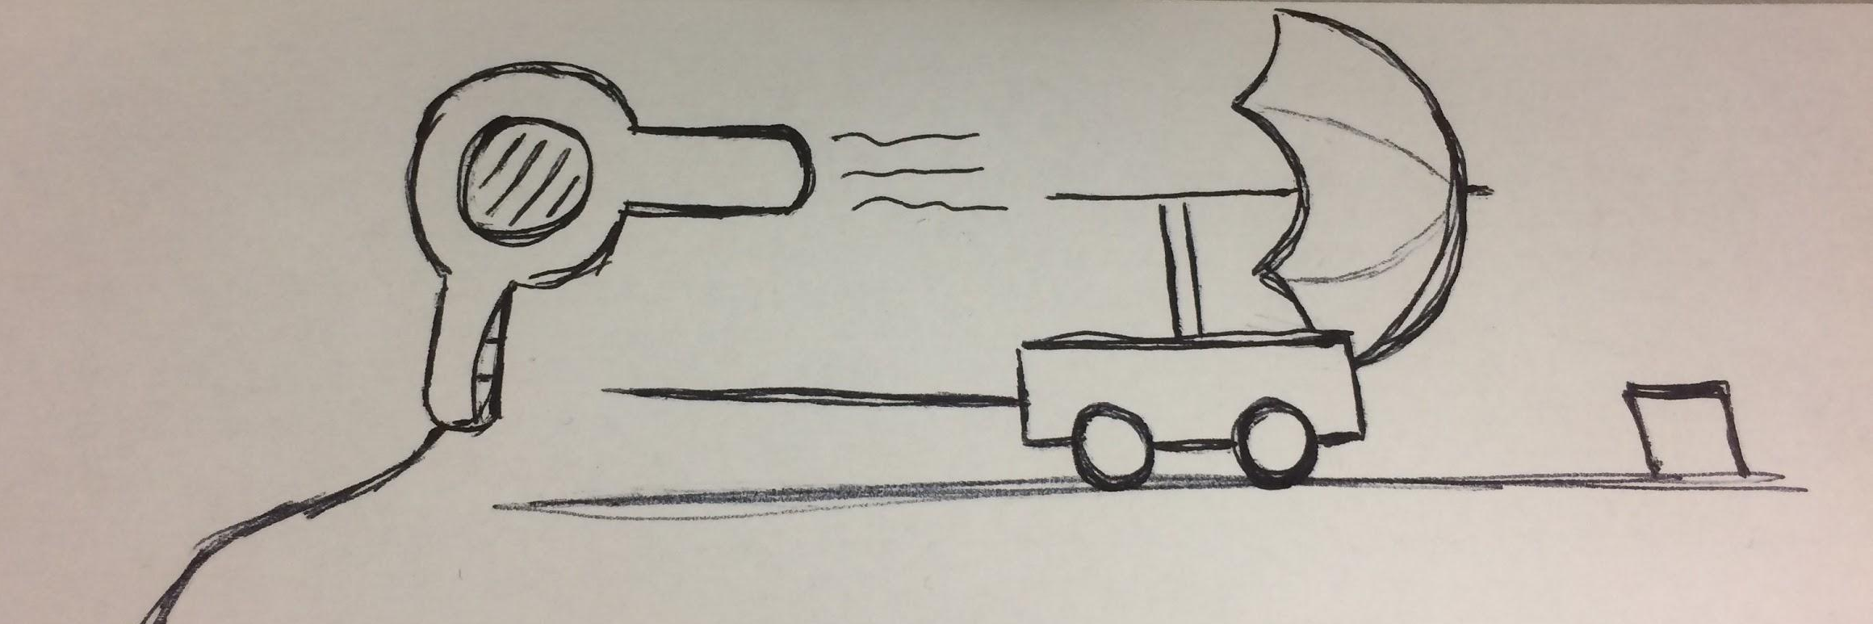
Figure 10: Datum, Hair Dryer Propelled Sail Design

Punching Arm
Figures 3 and 4 show the scissor lift prototype that modeled the motion of the design. This design incorporated Rube Goldberg’s cartoon inspiration as well as entertainment value and collapsibility. The punching scissor lift design shown in figure 11 was picked as one of the first steps to pursue. Compared to the datum design in figure 10, it met or exceeded the datum for meeting optimal values for the engineering requirements. It would be self-resetting, easy to follow, and have a quick run time.

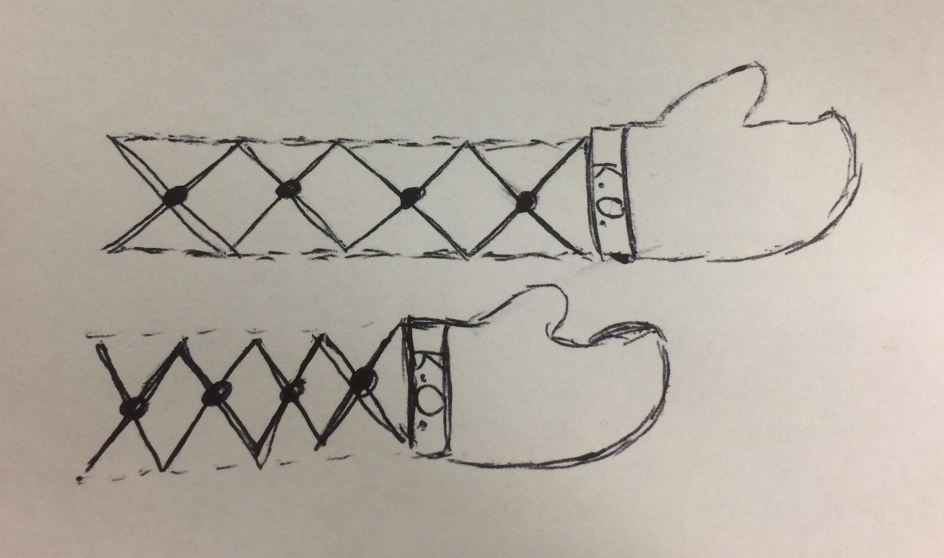
Figure 11: Punching Arm Design.

Newton’s Cradle
Another design considered was Newton’s cradle, as shown in figure 5. A newton’s cradle demonstrates conservation of momentum in a fun and easy to follow way [4]. As mentioned in section 3.5, it only needed the previous step to set it off so that the final ball swings up setting off the sequential step. As long as the step that got the momentum from the balls is also resettable, then the cradle will be considered self-resetting. The primary disadvantage of this design was its lack of cartoon inspiration. Otherwise, it was reliable and had proven to work consistently across a large number of manufactured cradles on the market [4].

Centripetal Force Mobile
The centripetal force design show in figure 6 was completely self-resetting, easy to follow, and durable. When the motor for the design is actuated, the weights start to slowly lift outwards as the rotational speed of the fulcrum increases. After the motor turns off, the weights will gradually return to their same position. It was easy to follow because it takes several seconds for the weights to reach the desired position from spinning. The disadvantages of this design were its run time and size. The design took up considerable space, and took up more time to run than other steps, which were limited by competition parameters.

Dual Pendulums
The dual pendulum prototype shown in figure 7 was a good show of the transfer of energy. The advantages of this design were that it was self-resetting, easy to follow and durable. The design was self-resetting because after the two pendulums loss all of their motion, they will eventually return to their initial position. Also, it was easy to follow and durable because the design only depended on the motion of two pendulum and it was built on rigid materials. It was also large enough to be easily view to audience. However, the disadvantages of the design were run time, reliability and cartoon inspiration. The time that the second pendulum started to take motion of the first pendulum took more than five seconds. Also, the second pendulum could have issues reaching its maximum momentum, keeping it from interact with the next step.

Rolling Jar
The Roller Jar Design shown in Figure 8 was considered for several reasons. It was resettable since the rubber bands attached to the weight in the middle of the jar are go back to their original tension after its motion was completed. After the jar is knocked in a direction, tension will grow in the rubber bands inside of the jar, and their stored energy was released and the jar reverses direction and moves in the opposite direction. It was also entertaining because the motion of the jar reverses as if by magic, and was also easy to follow because its movement was clearly visible. The sketch of roller jar step is shown below.

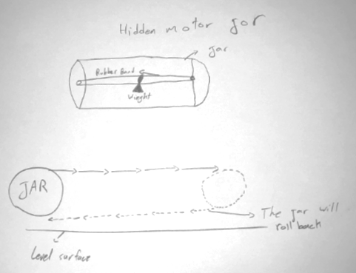
Figure 12: Rolling Jar

Bunny Bellow
The bunny bellow design in figure 9 was quite intricate and incorporated several steps. An important distinction between this design and other considered was its animal integration, which were prevalent in Rube Goldberg’s cartoons. It was entertaining, added easy consecutive steps to address the 30 step minimum requirement, ran to completion in about 10 seconds, and could be made completely self-resetting. A disadvantage of this design was that the progression of steps may be hard to follow.

Toothbrush Switchblade
Figure 13 shows a possible design for the toothbrush. This design incorporated a spring that flung the toothbrush out to prepare it for toothpaste application, which is the final step of the chain reaction machine. It is important that this step directly contributed to the final task as was entertaining and reliable. It was able to be completed almost instantly, meaning it would help us to adhere to the time limit. Planning ways to make the step resettable has been challenging.
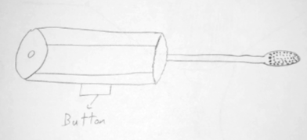

Figure 13: Toothbrush Switchblade Design

Gear System
This next design was a solution to two major customer requirements; being self-resetting and incorporated a human into the step. The gear system sketched out in figure 14 was a simplified version of the aspect that has a human input. There is a handle on a large gear that some person would turn in a circle which is connected to other gears that will be put in motion. These gears were the mechanism of reset for many of the steps in the assembly. For example, it was planned connect to the bunny bellow step in figure 9. Substep 4 shows the bunny being lifted back up by this mechanism. It also is not a step in the chain reaction machine, so it will not contribute to the step or time requirements. One issue we encountered with the design was that the machine could be difficult to travel with considering the building and integration of the design.
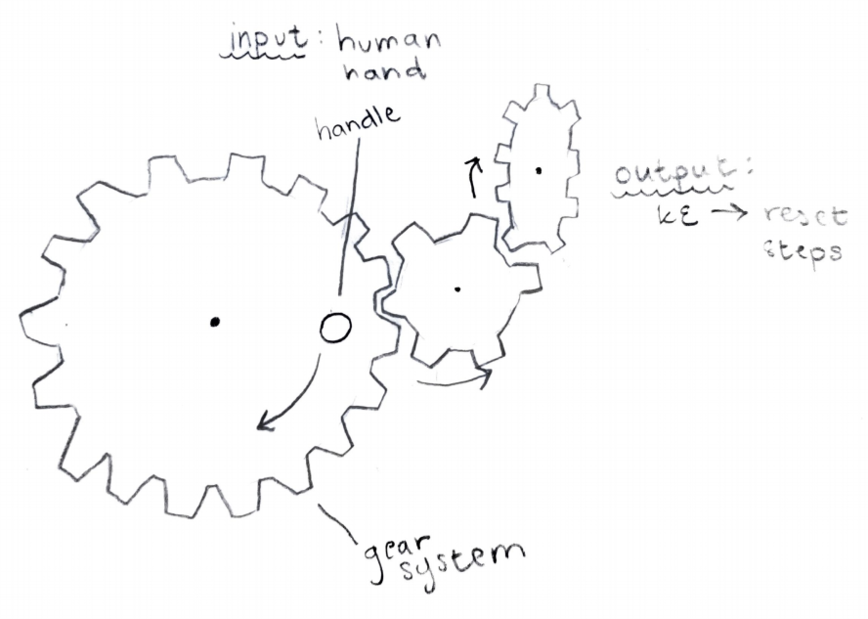
Figure 14: Gear System Design

Coin Funnel
A fun design considered by the team was reminiscent of a coin funnel that are often used for fundraising. The concept was a type of hyperbolic funnel that a coin appears to defy gravity by rolling straight up around the inside of the funnel, going faster and faster towards the center mimicking the orbit of planets around the sun [5]. Figure 15 displays how the basic design was implemented inside the chain reaction machine and how it was incorporated into the steps. This was a fun design, however it has been difficult to self reset, is not cartoon inspired, and has a large run time. It was reliable, durable, easy to follow, and entertaining.
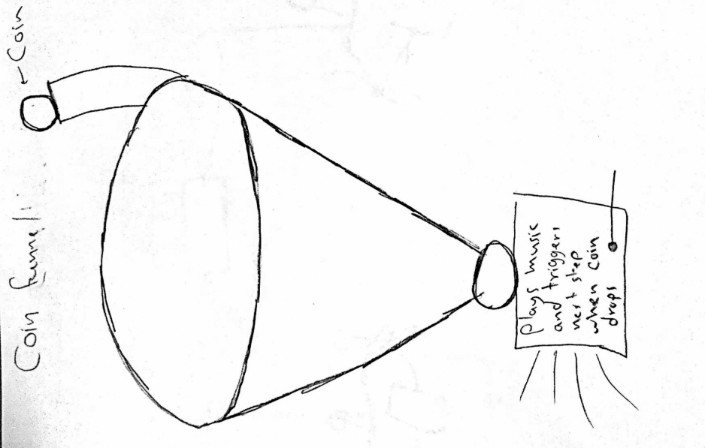
Figure 15: Coin Funnel Design

Levitating Ball
The levitating ball step in figure 16 was interesting because it incorporated the use of arduino and sensors. This step was self resetting as long as the hair dryer could be turned off and was both easy to follow and its action could be completed quickly. It also opened opportunity for the next step to be automated. A disadvantage was that it was not very cartoonish or entertaining, compared to other considered designs and the datum. It also required sensitive set up which could have made shipping this particular step challenging.
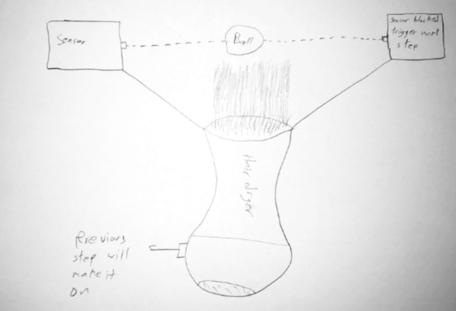
Figure 16: Levitating Ball Design

5 Design Selected
The chain reaction machine requires at minimum 30 steps before the toothpaste is put on the toothbrush and the task is completed. Considering the past team included 10 steps, al of which were successfully prototyped, the team needed a minimum of 20 steps. This means that of the steps considered could be implemented to the final product. The following subsection explains the criteria for selection of designs. It also includes thorough descriptions of all the selected designs.

5.1 Rationale for Design Selection
The tools used for analyzing all the designs considered were a Pugh chart and a Decision matrix. The Pugh chart was used initially to narrow down the step design ideas. For the analysis, design criteria were derived from the customer requirements, which were used for both the Pugh chart and Decision matrix. Initially 33 designs were considered during the Pugh chart analysis and the 10 designs with the highest scores were used. The pugh chart that was used can be found in figure A.1 to figure A.7 of appendix A. The highest ranked designs from the Pugh chart were then evaluated in the Decision matrix, which were then prototyped. The decision matrix shown in figure B.1 and Figure B.2 of appendix B.

5.2 Design Description
The designs with highest weighted score in the decision matrix were selected for prototyping. Shortlisted designs for the prototyping are shown in figure 17 through figure 23.

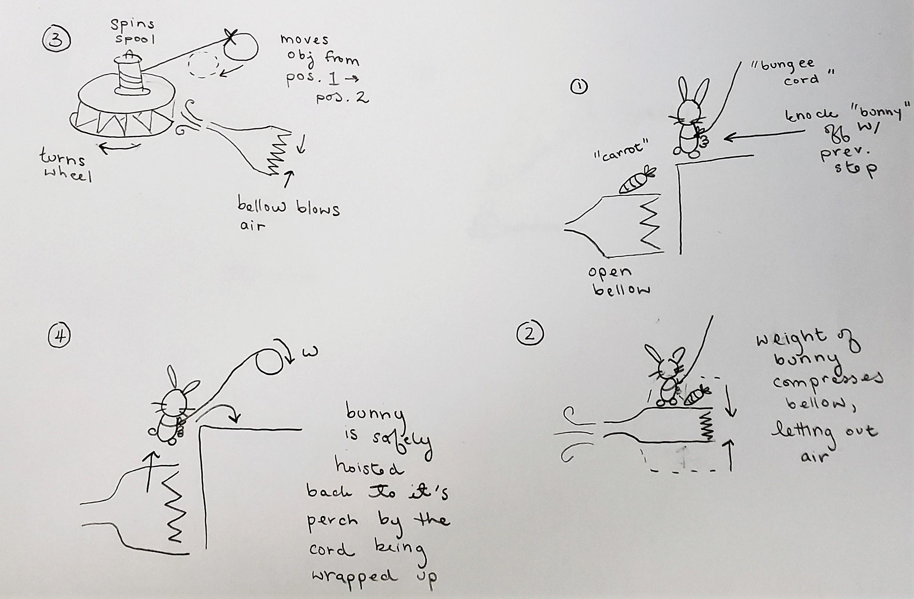
Figure 17: Bunny Below step
The step consisted of four individual steps. All the individual step presented in the figure 17 could be made resettable, a main requirement of the project. The step utilized a bunny and a bellow, helping enhance the fun element of the step. As arms of the bellow are compressed by the falling rabbit, air is blown out of the nozzle of the bellow, which then started the rotation of the spinner. These individual steps were combined with the hair dryer cart step that was created by the previous Rube Goldberg design team.
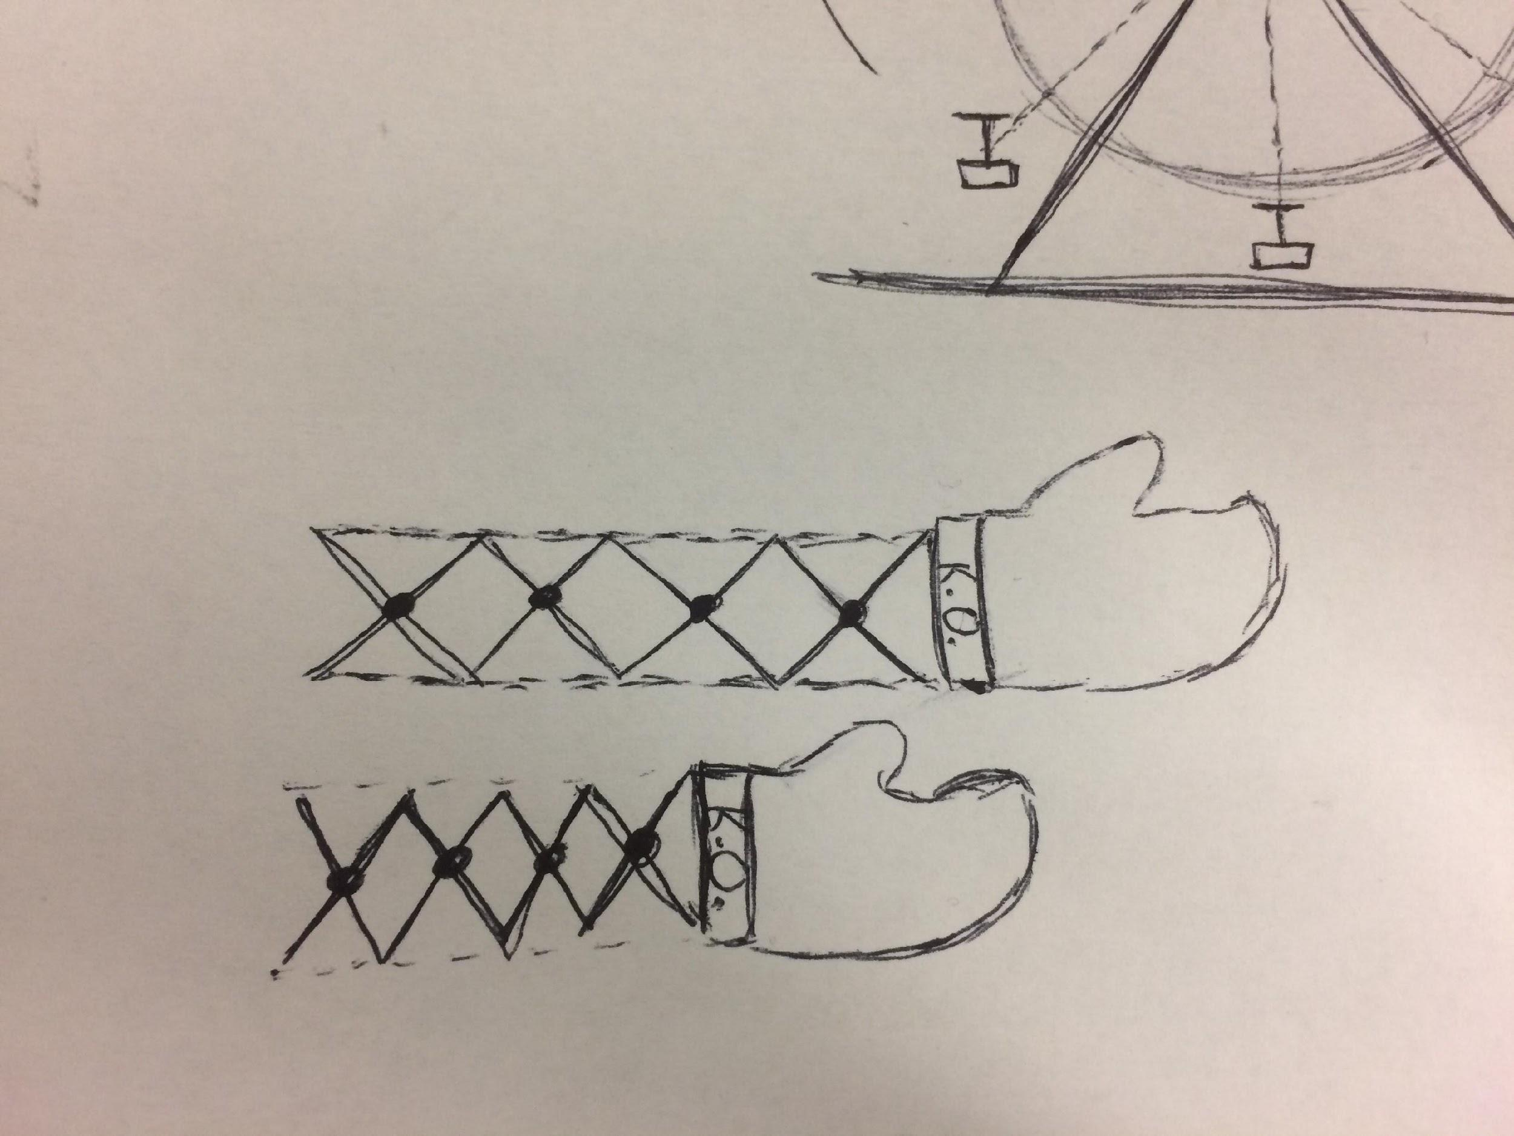
Figure 18: Scissor Lift Figure 19: Glove Attachment
The punching arm scissor lift is presented in figures 18 and 19. A punching glove will be attached to the end of scissor lift. The glove moved with the motion of scissor lift and was utilized to trigger the next step of the machine.

Figure 20: Rolling Jar

Figure 20 shows the rolling jar mechanism. A rubber band and weight was attached in the center of the jar, that winds up when rolled, building potential energy. When the energy was released, the jar jettisoned in the opposite direction of the initial roll, making contact with the next step.

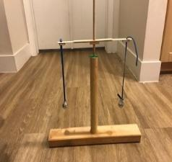
Figure 21: Centripetal Force Step

A DC motor was attached to the center stick. As the DC motor rotated, the balls attached to it started rotating. Due to the centripetal force the balls started to lift the weights and increased its height to hit the following step. When the DC motor was turned off, the weights were returned to their original position.
Figure 22: Double Pendulum Step

In the step shown in figure 22, one pendulum was actuated by the previous step. Since both weights are connected by a common string, the initial motion of the first caused the motion of the second, which collides with a button to turn on the following step. The pendulums will eventually return to their original position as frictional forces act on them.

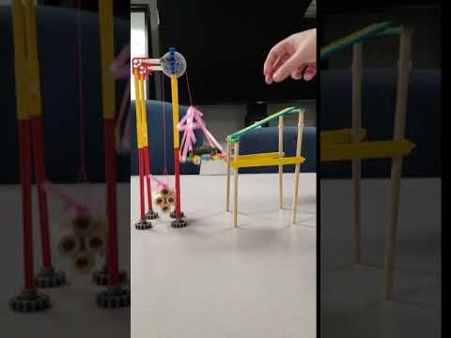
Figure 23: Mass and pulley system

The step presented in figure 23 was self-resettable. The pulley was offset by a weight that was heavier than the empty toy car carrier. Once the car reached the carrier, the carrier became heavier than the weight, and dropped down. Once the car left the carrier, the weight once again was heavier than the carrier, causing the carrier to return to its original position.

Previously, there were nine designs that have been prototyped, and 14 designs have been finalized. The first design was the punching arm shown in figure 19. An important factor in picking this design was that it was cartoon inspired, and was easily created and resettable. These factors were emphasised when choosing this design, as the group felt it was important to ensure the project felt fun. The second design that has been completed was the rolling jar model shown in figure 20. This design was been picked because of its entertainment factor, since it has the ability to change directions while rolling in all on its own. There are still some kinks to work out, like how to return it to its original position, which the team will continue to address. The dual pendulum design from figure 22 was another step that has been completed. It was easy to integrate because it may be set off by any perturbation and knocks the following step into place. The centripetal force design presented in figure 21 and the bunny bellow design from figure 17 have been completed. The bunny bellow design of figure 17 incorporated four separate steps in one design. Now that initial prototyping is complete, the team is now tasked with completing final designs of the steps and implementing them in an assembly.

6 Proposed Design
Our aim was to build a Rube Goldberg machine that applied toothpaste onto a toothbrush. 10 steps of the machine were fabricated by the previous team. Our team has combined our finalized steps with the steps of the previous team in our final model of the assembly. The base for all the steps were made on wooden supports. The current design utilizes Audrino, punching arms, toy cars, string, tinker toys, wooden plank and bellows. All of these were available either in stores or through online retailers. The detailed schedule for the current semester, are presented in a Gantt chart shown in figure C.1 and figure C.2 of the Appendix C. To complete the project, the team has utilized various resources, which are presented in the table 4.

Table 4: Resource List
Category | Name | Location | Expertise
Manpower | Amy Downhill | NAU | Student
Manpower | Nahar Alotaibi | NAU | Student
Manpower | Alivia Tongate | NAU | Student
Manpower | Angelo Cencioso | NAU | Student
Manpower | Abdulrahman | NAU | Student
Manpower | Almutairi | NAU | Student
Manpower | Hamad Almerri | NAU | Student
Advisor | Dr. Trevas | NAU | Instructor
Facilities | ME Department | NAU | Group Discussion
Facilities | Machine Shop | NAU | Part Fabrication
Facilities | 3D Printing Lab | NAU | Part Fabrication
Facilities | Wood Shop | NAU | Part Fabrication
Material Supplies | Local and Online Retailers | - | Purchasing
Funds | NAU | NAU | -

Total project budget allowed to the team is $1000 to $1500, out of which $500 to $1000 was fixed for material costs and remaining was allowed for shipping and transit. Up to the end of last semester, the team’s expenditures for out project amounted to $107.5, with the full breakdown given in figure 24. The updated bill of materials is detailed in the following sections.
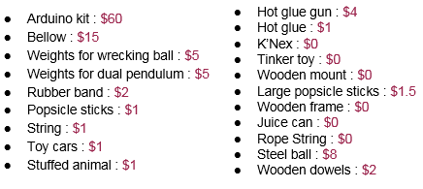
Figure 24: List of expenses, December 2018

7 Implementation

7.1 Manufacturing
At the beginning of this semester the goal was to have the machine built over a week before the competition. The chain reaction machine competition at Purdue was on March 2 so the deadline to complete the machine was February 23. Having the deadline be a week before competition would allow us to ship to Indiana in time. Week one of the semester was dedicated to putting all the ideas and prototypes together from the previous semester into a single assembly. Weeks two and three were set aside as time for the team to build the middle 20 steps. After this, the next two weeks were dedicated to coming up with the first and last five steps as well as any connection steps required between. Finally, the last week was to be designated for ensuring all steps worked together reliably and were as self-resetting as we could make them. Although, the primary goal was to have a working machine with a minimum of 30 steps by this time.

The primary material used in building the support and structure is wood. It is pretty cheap and easy to work with. Other seemingly random objects are another crucial part to this design such as; toys, shoes, bellows, 3D parts, and jars. An adhesive used is hot glue. Other methods of securing the pieces of wood in place include; screws, nuts, and bolts. The materials either came from items that were already owned, or were purchased from Goodwill, Home Depot, Amazon, or other online sources. The full breakdown of the list of materials used is listed in table D.1 in appendix D.

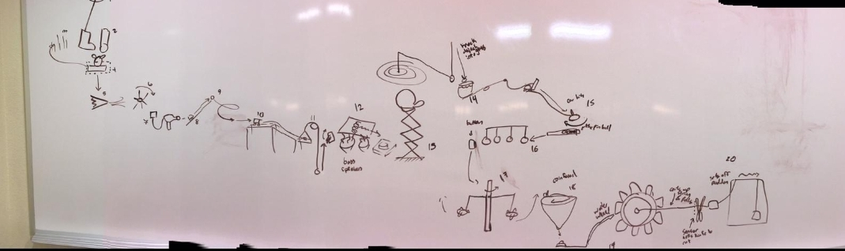
Figure 25: Sketch of the Middle 20 Steps

Implementing the first 10 of the 20 designed steps requires some arduino work, building of the supports, and integration of the previous teams steps. Steps 1-10 are shown on the left hand side of Figure _. The first step in manufacturing the first ten steps is building a single wall and shelves to hold the multi-level chain reactions shown in steps 1-6. Steps 7-9 are all recycled from the previous team so the plan was to use arduino to connect step 6 to step 7, which has all already been programmed by the summer team to work with steps 8 and 9. Step 9 is the trigger for the cart that then is used in the mass-pulley step (step 10) which has already been prototyped. From initial guesses, steps 1-6 would be the more time intensive steps to build considering steps 7-10 have already either been built or prototyped.

Step 1 comes from another year’s capstone team. It is a boot that rotates about a single point, and should not take much time to implement considering it is already built. The biggest problem here is figuring out how to integrate it into the support built for this year’s machine to work for this use. Step 2 is the rolling jar step, which has been prototyped but needs some work to be more reliable and specifically heavier. Any cylindrical object will do, ideally it will be recycled. The other material required for this includes a rubber band and a 9V battery. Which are all already owned by members of the team. Step 3 is a bowling pin setup that will be knocked over by the jar in step 2, using gravity it will trigger step 4. The plan is to use any kind of long object that can be easily found to be knocked over. Step 4 consists of a piece of wood that is planned to be set-up on wheels to minimize friction. It is pulled out by step 3 and releases the bunny toy of the bunny bellow step. The bunny will be held by a tube that just has a slit allowing for the wood to be inside the tube, then the walls of the tube will hold the bunny back so that it falls onto the bellow. The tube, bunny, and bellow are all to be bought from Amazon. Step 6 consists of a sort of turbine design that will be 3D printed to the appropriate dimensions. The assembly of these steps is shown in figure 26.

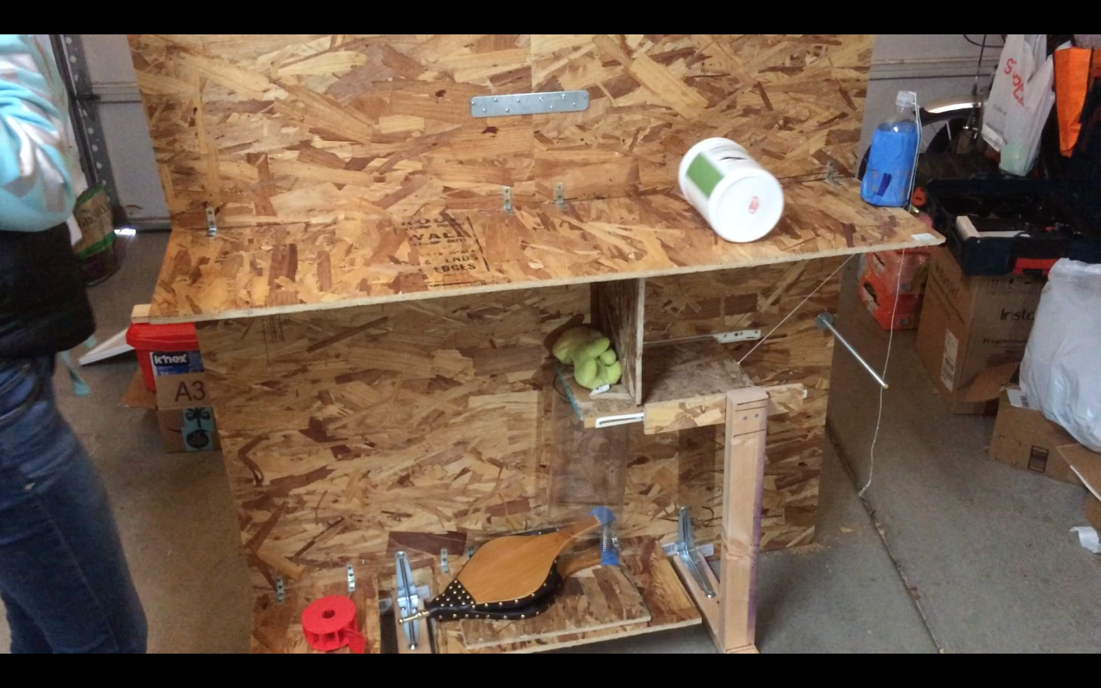
Figure 26: Expanded View of Assembly of First Steps

As mentioned before, steps 7-10 are either already built or prototyped so it will be easier to implement these. An arduino kit is also required to build these because it will be used to make everything as self-resetting as possible. Although, with the time limit the focus was on making the steps all work in one direction first and then potentially after the competition fixing the machine so that it is entirely self-resetting.

For the second 10 steps of our middle 20 steps, we have almost done with all steps. We will provide a brief description of some steps that already built. With manufacturing, we had problems with making them perfect placing to do the function for each step correctly For these steps. However, we had problems with finding the perfect tools to attach each parts with each other.

The Dual Pendulum step is implemented using a piece of string, two plastic supports and a wooden stand. The wooden stand is cut from a sock of wood and the small pieces that it comprises hammered together with nails. The plastic supports can be obtained from reusable materials. Holes are made on them to accommodate the pendulum string. Two standard metallic nuts are used as pendulum bobs and are strapped onto the string. These are all assembled to make up the pendulum step (Figure 27)

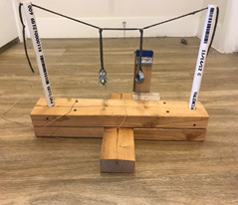
Figure 27: Dual Pendulum Step

The Pendulum is tightened with a string which you can see on the left. The string will be pulled and the magnet is released, this action happens from the previous step. When the magnet is released it will cause the pendulum to move and then the right one will move also because the energy and motion are caused. The right Pendulum will turn on the switch for the next step.

A working Newton’s Cradle was purchased and then placed onto a wooden support. Currently, only the wooden support needs to be fabricated. The pieces needed to make the support are cut from wood stock and glued together with wood glue. Once the support is ready, the cradle is fixed into it (Figure 28).
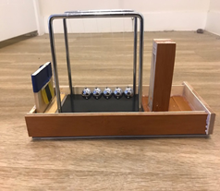
Figure 28: Newton's Cradle Step

The wrecking ball step combined with the coin funnel step, seen in figure 29, has the most parts. The wrecking ball assembly consists of two balls on strings strapped on a rotating wooden rod. The rotating wooden rod is attached to a rotary motor supported on a wooden stand. The entire assembly is powered by a DC as seen by the yellow wires in figure 29. The coin funnel consists of a funnel supported on a wooden stand and a ramp for delivering the coin to the funnel. The wooden stand is manufactured by cutting wooden pieces from a wood stock and gluing them together. The ramp is built from recycled plastic bottles cut in half. All these are assembled as shown in figure 29.

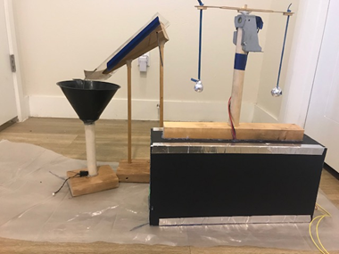
Figure 29: Wrecking ball step with coin funnel step

The car sliding step requires a ramp, a wooden stand, a rotary motor, a switch and a power source. The wooden stand is manufactured from a wooden stick. The plastic ramp is made from three pieces of styrofoam (white) cut from a single piece and glued together. The final assembly of the step is as shown in figure 30.

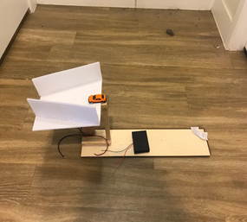
Figure 30: Car sliding Step

Next is the scissor lift step which is made from wooden stand, a wooden scissor lift (made from a recycled coat rack purchased from Goodwill,a relay switch and two styrofoam plastic pieces to form the glove shape. Like the previous step,the styrofoam was made from a single piece that was already available to the group. The relay is purchased as is together with the Scissor Lift. The wooden stand is fabricated using two chunks of wood from a wooden stock glued together. The parts are then assembled to form the scissor lift step as shown in figure 31.

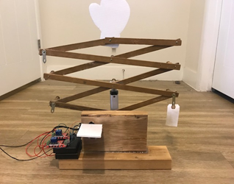
Figure 31: Scissor Lift Step

Next step is the dual weighted see-saw Figure 32. It consists of 4 parts and a wooden stand. The first part is the cup which is a recycled plastic container. The next is a plastic rod glued onto the plastic cup. This rod is attached to the first see-saw portion made of wood. The second see-saw portion is also made of wood and is attached to the opposite end of the first see-saw. The entire assembly is shown in Figure 32.

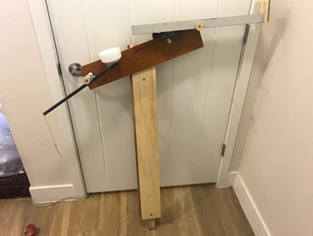
Figure 32: dual weighted see-saw

For this step, we need the scissor lift to punch it and make it balance. The scissor lift shown in Figure 31 will punch the silver part on the right of figure 32 while doing that there will be a ball which will drop and route on the white cup which will pull the string that will be attached on Newton’s cradle shown in Figure 28.

7.2 Design Changes
In reality, the building process took much longer to get correct than desired. By the third week we encountered a number of issues, including shipping delay and time constraints preventing us from being able to build everyday. We were behind in building and the middle 20 steps in reality had not been completed. Since we were behind, the team decided that we would not be able to create a quality product in time for competition. The late deadlines, final time constraint, and higher fees for last minute shipping and travel all added to the final decision to not attend the competition in Purdue. We decided to instead compete with the University of Arizona on April 20, since they were not able to attend the Purdue competition either. UGRADS also took place April 26 so the team was required to finish before then.

The first iteration of steps 1-6 were constructed using a single piece of oriented strand-board (OSB) wood of dimensions 4 ft. x 4 ft.. A large board of OSB of that size cost $16.74 at Home Depot. It was easy enough to work with and had minimal splintering, although some parts that were overworked, as in having too many holes and cuts within a couple inch radius, did break and have to be replaced. The single structure piece held up another smaller piece of OSB that served as a ramp that held onto the rolling jar step. The jar was made out of an empty protein powder jar, two rubber bands, two paper clips, and a 9V battery. After building this shelf level to start, it was later angled to allow for a faster moving roll into the pins. The pins for prototyping were cardboard toilet paper roll holders. Unfortunately, these were too light so they were updated in the second iteration. The wooden board in step 4 was constructed out of a drawer mechanism. The drawer parts were found at Home Depot, the wooden piece was made of OSB, and was held in place using both screws and other pieces of OSB board that were also screwed into the support piece. The tube was bought on Amazon and it was positioned just below the drawer. Another cut down piece of OSB was used to hold the bunny back from being pulled along with the drawer to direct the falling stuffed animal onto the bellow. The tube was drilled through twice and zip tied to the support board. The zip ties were already owned. In this iteration the bellow had not been secured to anything so it was just resting on the ground, which caused it to be unreliable. The turbine had been 3D printed in the makerlab at NAU, used 105.43 grams of filament and cost $10.54 [6]. It spins using a fidget spinner that was already owned. The design allows for the center of the spinner to fit within a hole at the bottom of the turbine so that it spins freely along with the arms of the spinner. This wall was held up by two pieces of wood, cut down from a larger part found in the discount section of Home Depot.
Another iteration of these 6 steps had to be made because the first iteration was not easy to break down, transport, and build up. The solution was to use two separate pieces of OSB board connected by an extension bracket, nuts, and bolts. Instead of using the original set-up for the boot, a hole was drilled that could be used to hold the arm attached to a servo motor that will control the kicking motion, and allow for it to be self-resetting. A similar strategy for the first shelf was used. A one foot wide piece of OSB board served as the shelf, it was positioned at a slight angle. The board was attached to the board using L-brackets to protect it from sheering. The same jar was used for step 2 as in the first iteration. The original cardboard toilet paper rolls were replaced with a plastic water bottle filled with rocks which were positioned to offset the weight towards the top of the bottle. This allowed for a greater pull force to counteract the frictional forces opposing the drawer’s movement. Both materials were already owned. A rod was positioned in-line with the back of the drawer to give the water bottle an arm to drape over, allowing the drawer to be pulled back during the bottle’s falling motion. It took some experimentation to get the correct length of string to connect the drawer to the bottle, given the height of the water bottle and height of the drawer and rod. A similar piece of OSB board holds back the stuffed animal. Four pieces of wood were connected at the bottom of the support using L-brackets and screws, serving as feet for the design. One of the feet is connected to a long plank that holds the drawer up using its metal rail components. The tube remained in the same position from the previous iteration. This iteration features two additional shelves located at bottom of the wall to hold the bellow, which is secured in place by two screws, and the turbine. Both shelves are supported by L-brackets and screws.

After finishing the first 20 steps of the assembly, the team had to change and create new designs for the remaining 10 introductory and finishing steps. The first four steps in the assembly were constructed off of the hair dryer cart assembly. Two 2’’ x 4’’ beams were used to make the structure for the LED light strip and mail arm. Two small L-brackets were used on each beam to connect foot supports to each. A connecting plank of wood was strung between the supports to hold the LED strip. A wood plank was attached to the back of the hairdryer-cart assembly and the main step structure to make it a single structure. The mail arm was constructed using a 3D printed case, continuous rotation servo, a binder clip, and a piece of mail. The full assembly for the mail arm step was attached to the supports using wood screws. All of the electronics were run using an Arduino Uno board. For operation, a red button is pushed on the left hand side of the structure, which turns on the LED light strip. Individual lights run across the string, and once the full string is run, the mail arm extends and contracts. These steps are entirely self resetting. The full assembly of these steps is shown in figure 33.

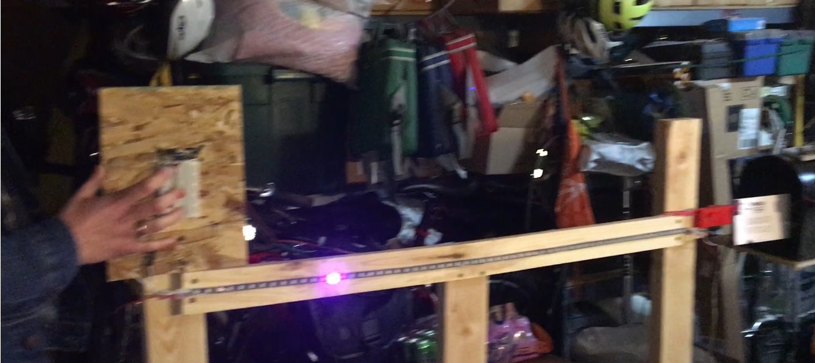
Figure 33: Assembly of Steps 1 and 2

Next, the connecting steps were built between the first two steps and the middle steps attached to the OSB support structure, which is the mailbox assembly and wood swing arm. A support shelf was built onto the back of the OSB support structure using small L-brackets and wood screws to hold the mailbox. A servo motor was secured to the outside of the mailbox to drive the action of the mail arm. A proximity sensor was placed inside of the mailbox to register the motion of the mail arm, which then rotates the mail arm 90 degrees. Another proximity sensor was attached to the top of the mailbox to register the motion of the mailarm, which starts the action of the swing arm, which contacts with the rolling jar step. The swing arm was attached to the OSB support structure using bailing wire and threaded rods. The swing arm was attached to the motor using a plastic snap attachment. All of the electronic components were run using two Arduino Uno boards. These steps are completely self resetting. These steps incorporation into the assembly is shown in figures 34 and 35.

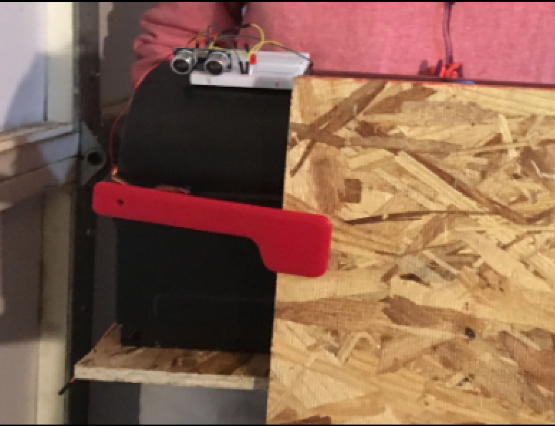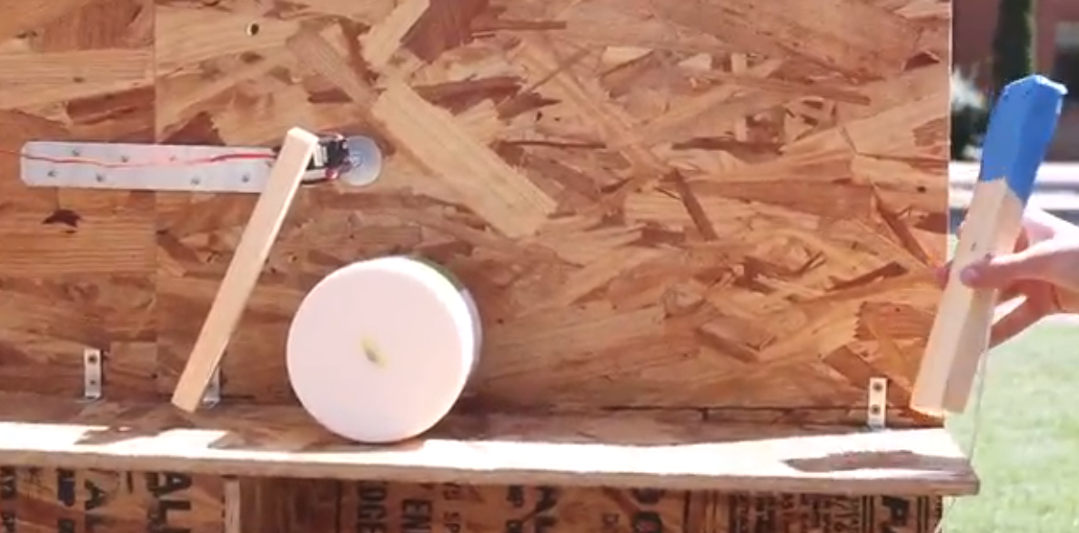
Figure 34: Mailbox Step in Assembly Figure 34: Steps 4-6 in Assembly

After, the connecting steps between the middle OSB structure and hairdryer-cart step was manufactured. Since the hairdryer-cart step was created by the previous Rube Goldberg team, we were forced into using a button push start to actuate the hairdryer, instead of using proximity sensors like we did for many of our other steps. With this in mind, we needed to create a step that would be able to stay in contact with the push button start. The team created a lever arm, that when loaded with weight would contact and keep contact with the button. We built a connecting arm between the bottom shelf of the OSB support and the bottom of the hairdryer-cart step. A catch basin was added to one end of the lever arm, and a bolt was secured to the other end to make contact with the button. A threaded rod was sent through the middle of the lever arm and the right hand 2’’ x 4’’ support of the first two steps to keep it in place. Zip ties were placed around the bottom leg of the hairdryer-cart ramp and the lever arm to keep it from moving laterally. As weight is moved into the catch basin, the vertical position of the lever arm changes to make contact with the starter button. This step is shown in figure 36.

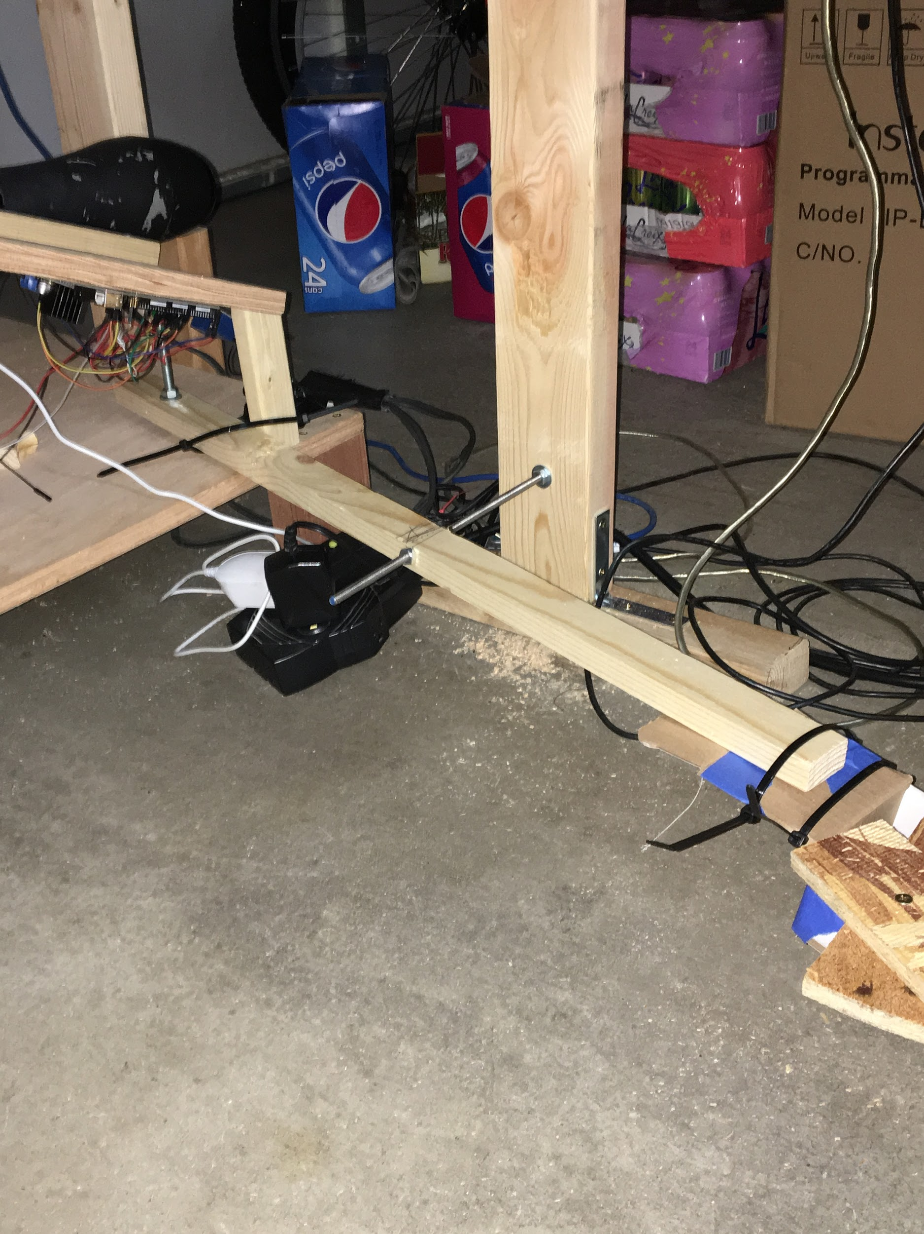
Figure 36: Lever Arm Step in Assembly

A cart was not provided by the previous team Rube Goldberg team for the hairdryer-cart step, so the team manufactured one out of legos. This cart was significantly smaller than the one that was originally used, so we had to reposition the directing rails on the assembly. To catch the air coming out of the hairdryer, a balloon was attached to the cart, as shown in figure 37.

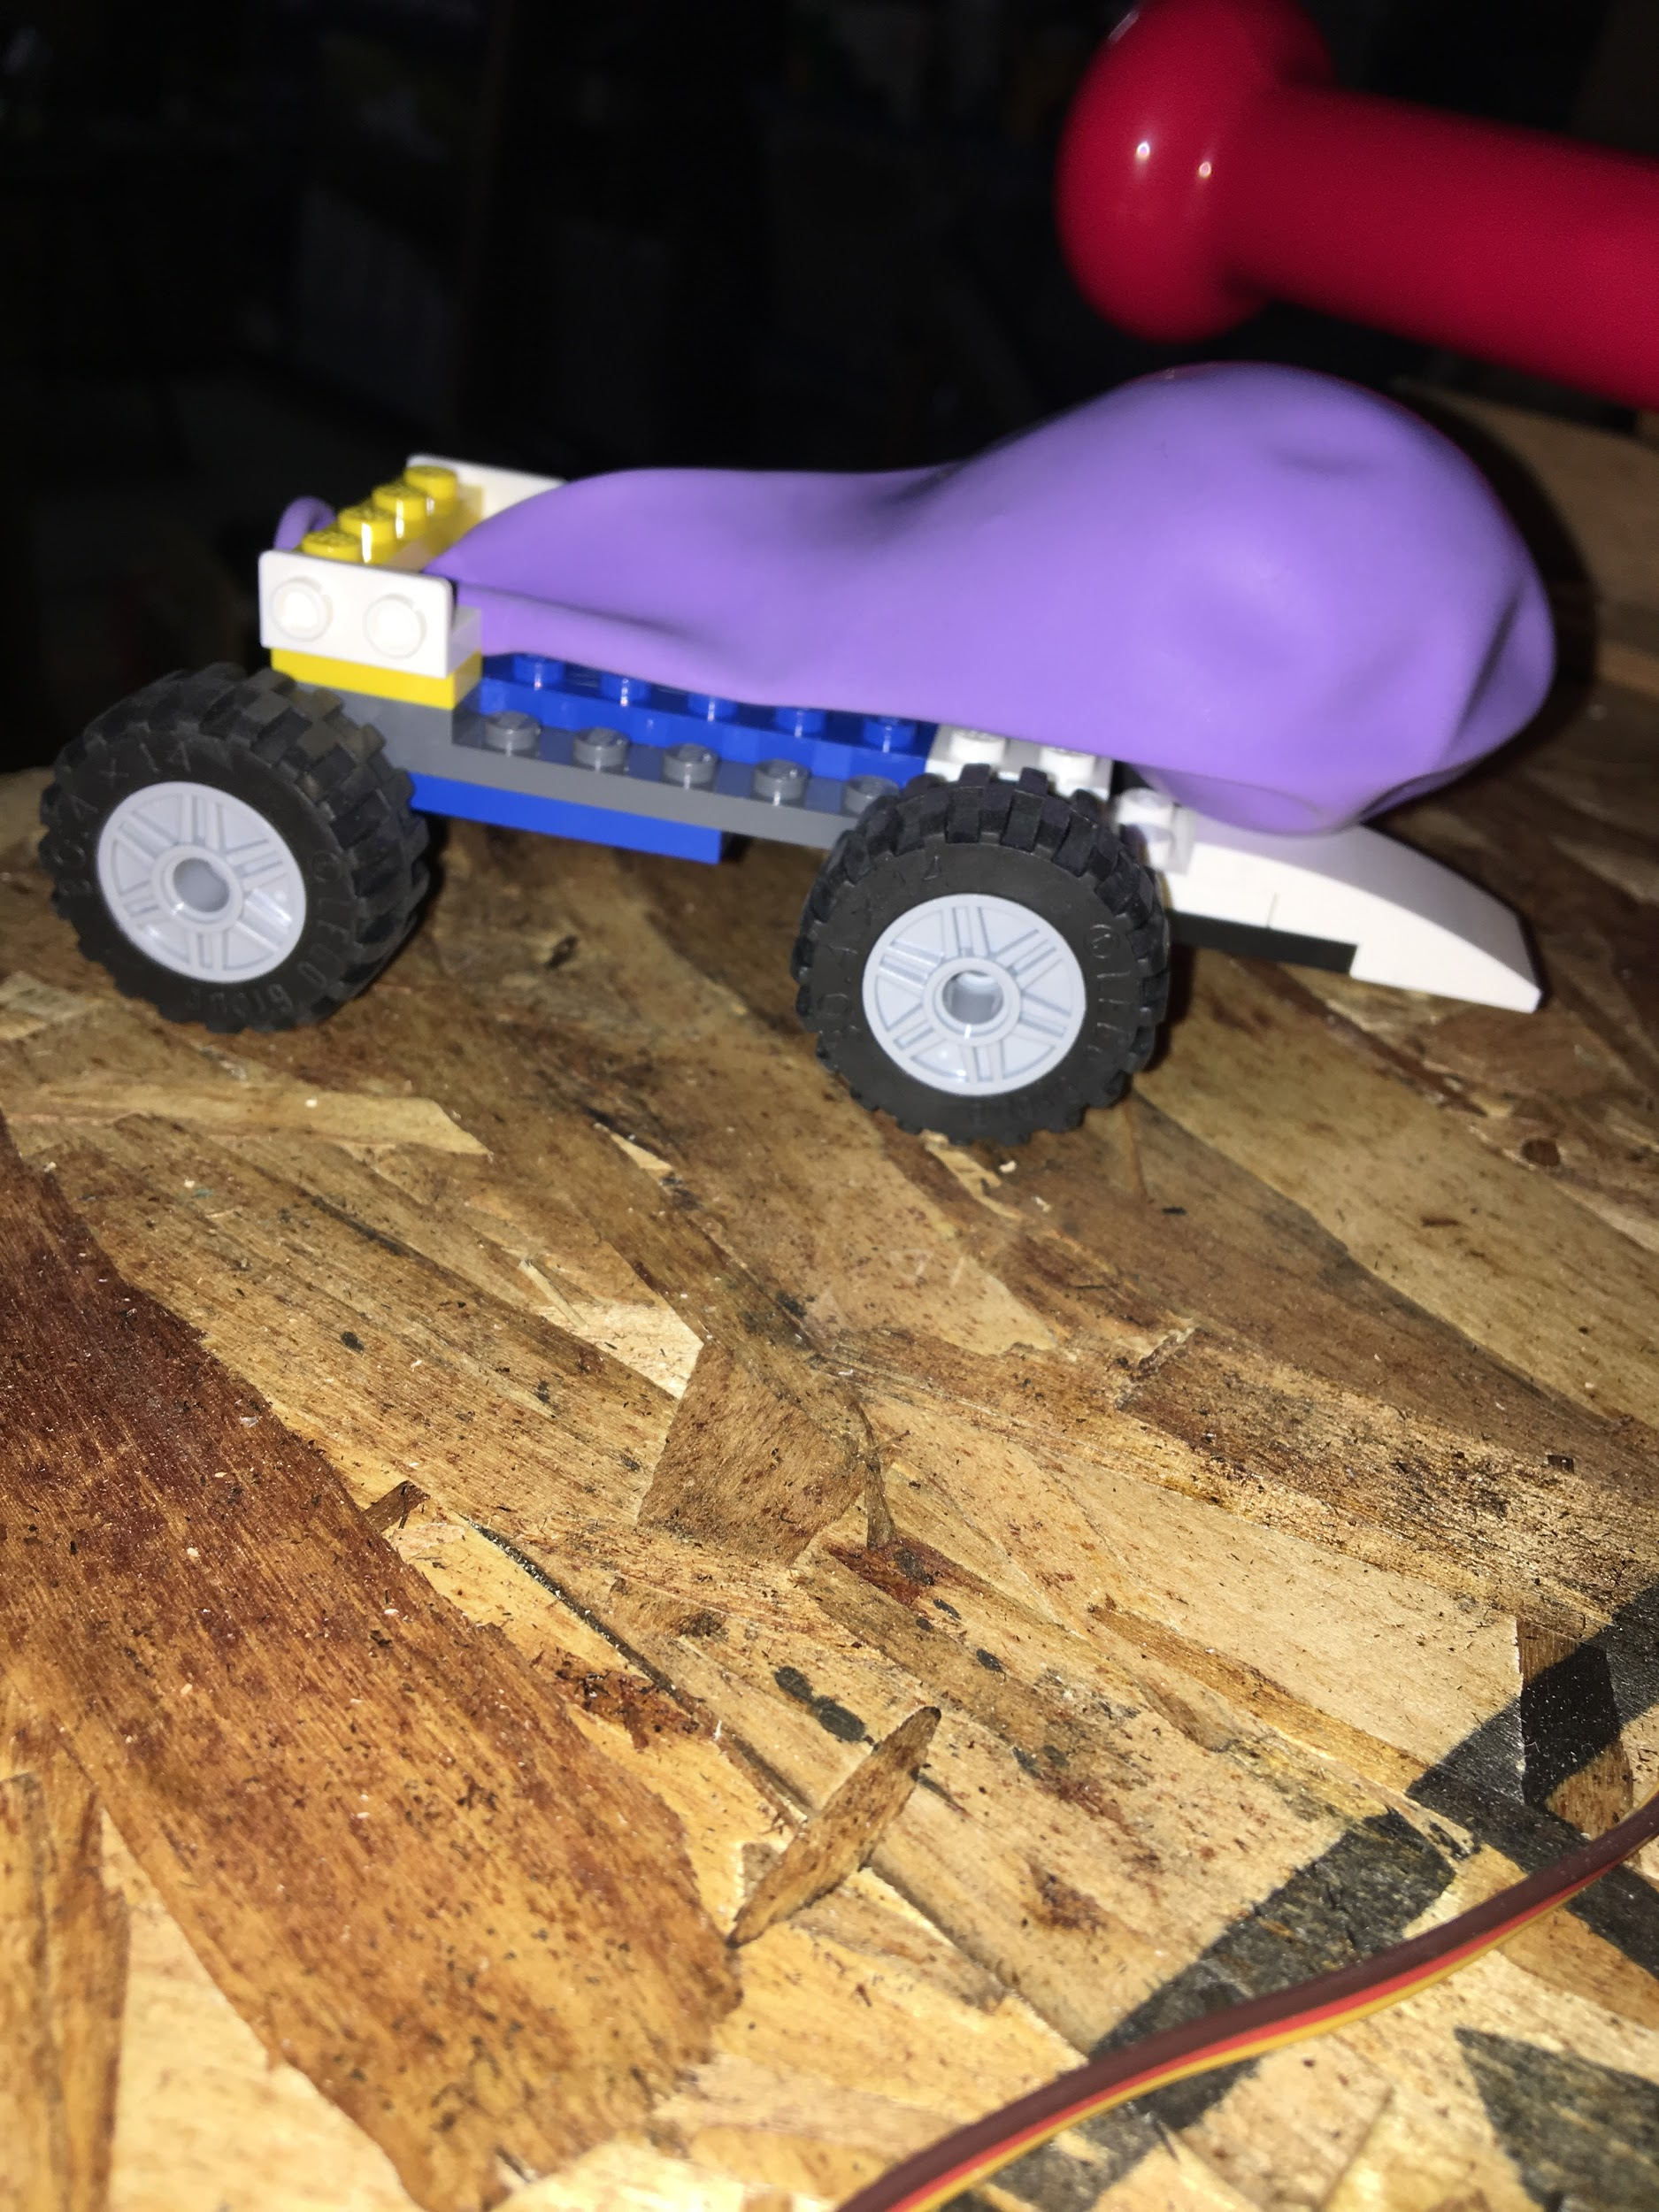
Figure 37: Lego Cart for Hairdryer-Cart Step

The next steps of the assembly were also built off of the hairdryer-cart assembly. A raised platform was added to the front of the cart assembly to hold the bat swing step and ball bearing weight. A small OSB piece was secured to the top of a 2’’ x 4’’ wood piece, which was secured to the cart support using long screws and a threaded rod. The bat swing was creating using a servo motor and a small plastic toy bat. The servo motor was secured to the OSB piece using bailing wire. The rolling motion of the cart discussed above triggers a proximity sensor which starts the motion of the bat. The bat comes into contact with a ball bearing that is elevated by superglued nuts. Once the bat makes contact with the ball bearing, it is directed toward a small diameter clear tube using wooden rails attached using wood screws. The tube is attached to the OSB platform using zip-ties. Once the ball reaches the tube, it rolls down and exits the tube to enter the next step, starting its motion. This part of the assembly is shown in figures 38 and 39.

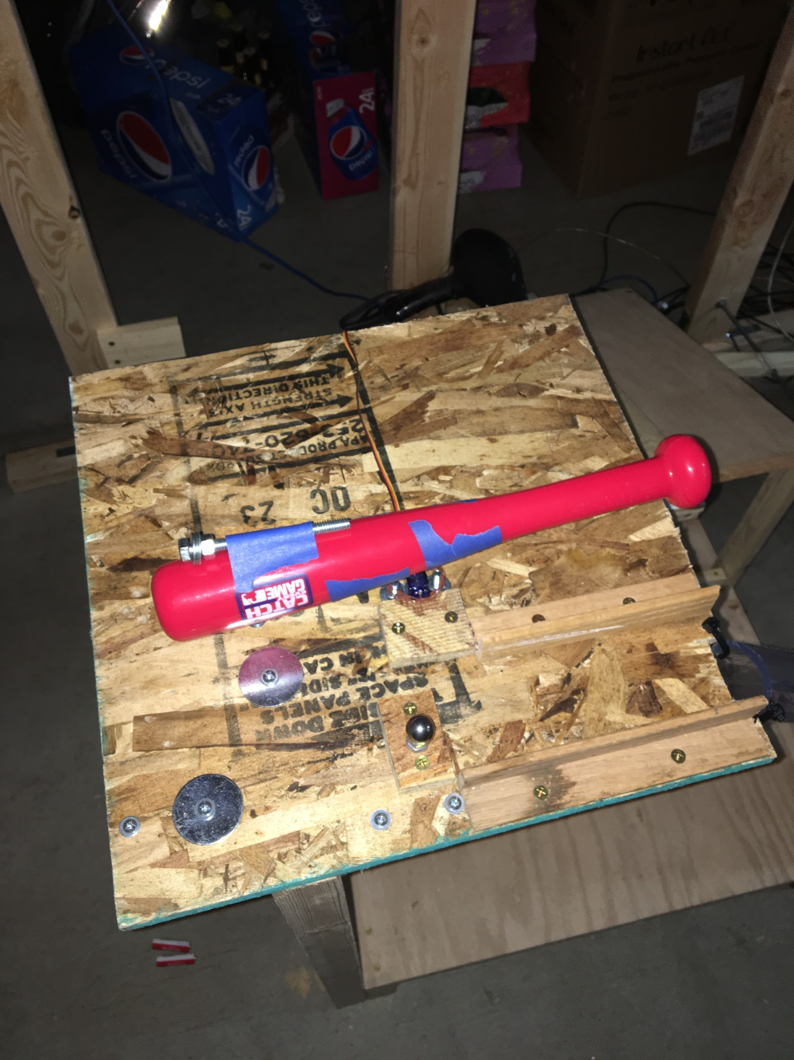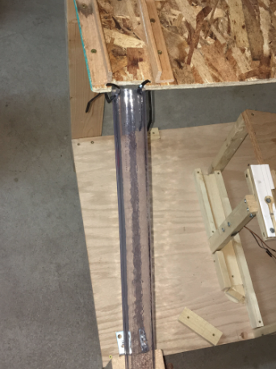
Figure 38: Bat Swing, Ball Bearing Figure 39: Ball Bearing Delivery Tube

The final version of the mass pulley step was created. Once the ball bearing weight enters the soap box entry, it is enough to surpass the weight force of the wooden block on the other side of the conveyor belt. As the soap box drops, the wooden block moves upwards, making contact with a switch that starts the cart sliding step shown in figure 30. The finished mass pulley and cart sliding steps are shown in figure 39.

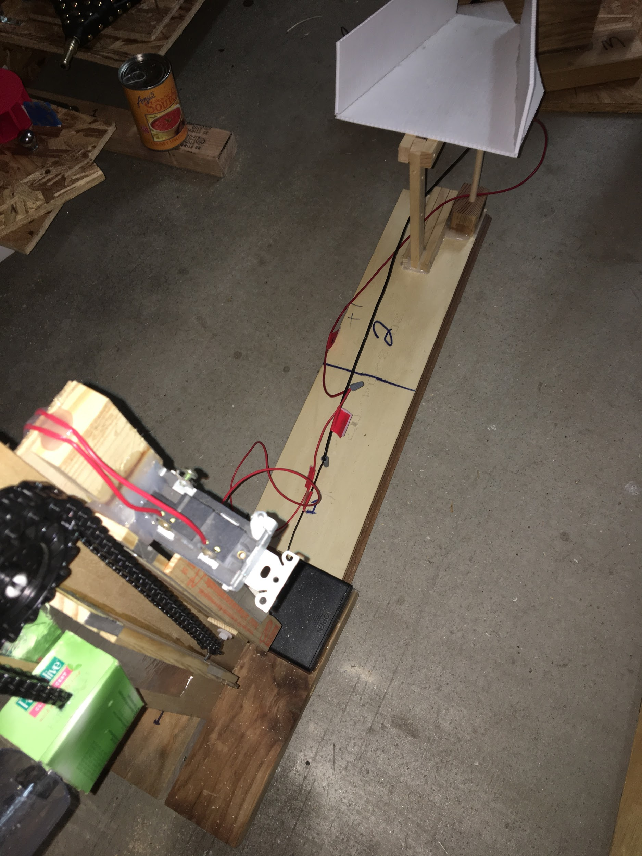
Figure 40: Mass Pulley Step, Cart Sliding Step Connection

The scissor lift punch arm step is positioned right under the cart sliding step to allow the toy car to start its motion. The dual weighted see-saw shown in figure 32 is positioned right over the punch arm to start the motion of the plastic ball. The Newton’s cradle step in figure 28 is then attached to the white cup on the see-saw to start its motion. Once the cradle makes contact with its switch, it starts the motion of the wrecking ball step shown in figure 29. Once the wrecking ball hits the coin stopper out of the coin railing, the coin is released into the funnel which then starts the next step, as shown in figure 29.

The previous Rube Goldberg team built a water wheel step, but it did not function well enough to utilize in our design, and the step was completely rebuilt. During operation, the water pump turns on, whose nozzle is aimed at the arms of the water wheel. As the wheel turns, it starts to coil a tether that is attached to one of the pendulums of the dual pendulum step. Once the tether is pulled tight enough, it releases from the pendulum, starting its motion. This is shown in figure 41.

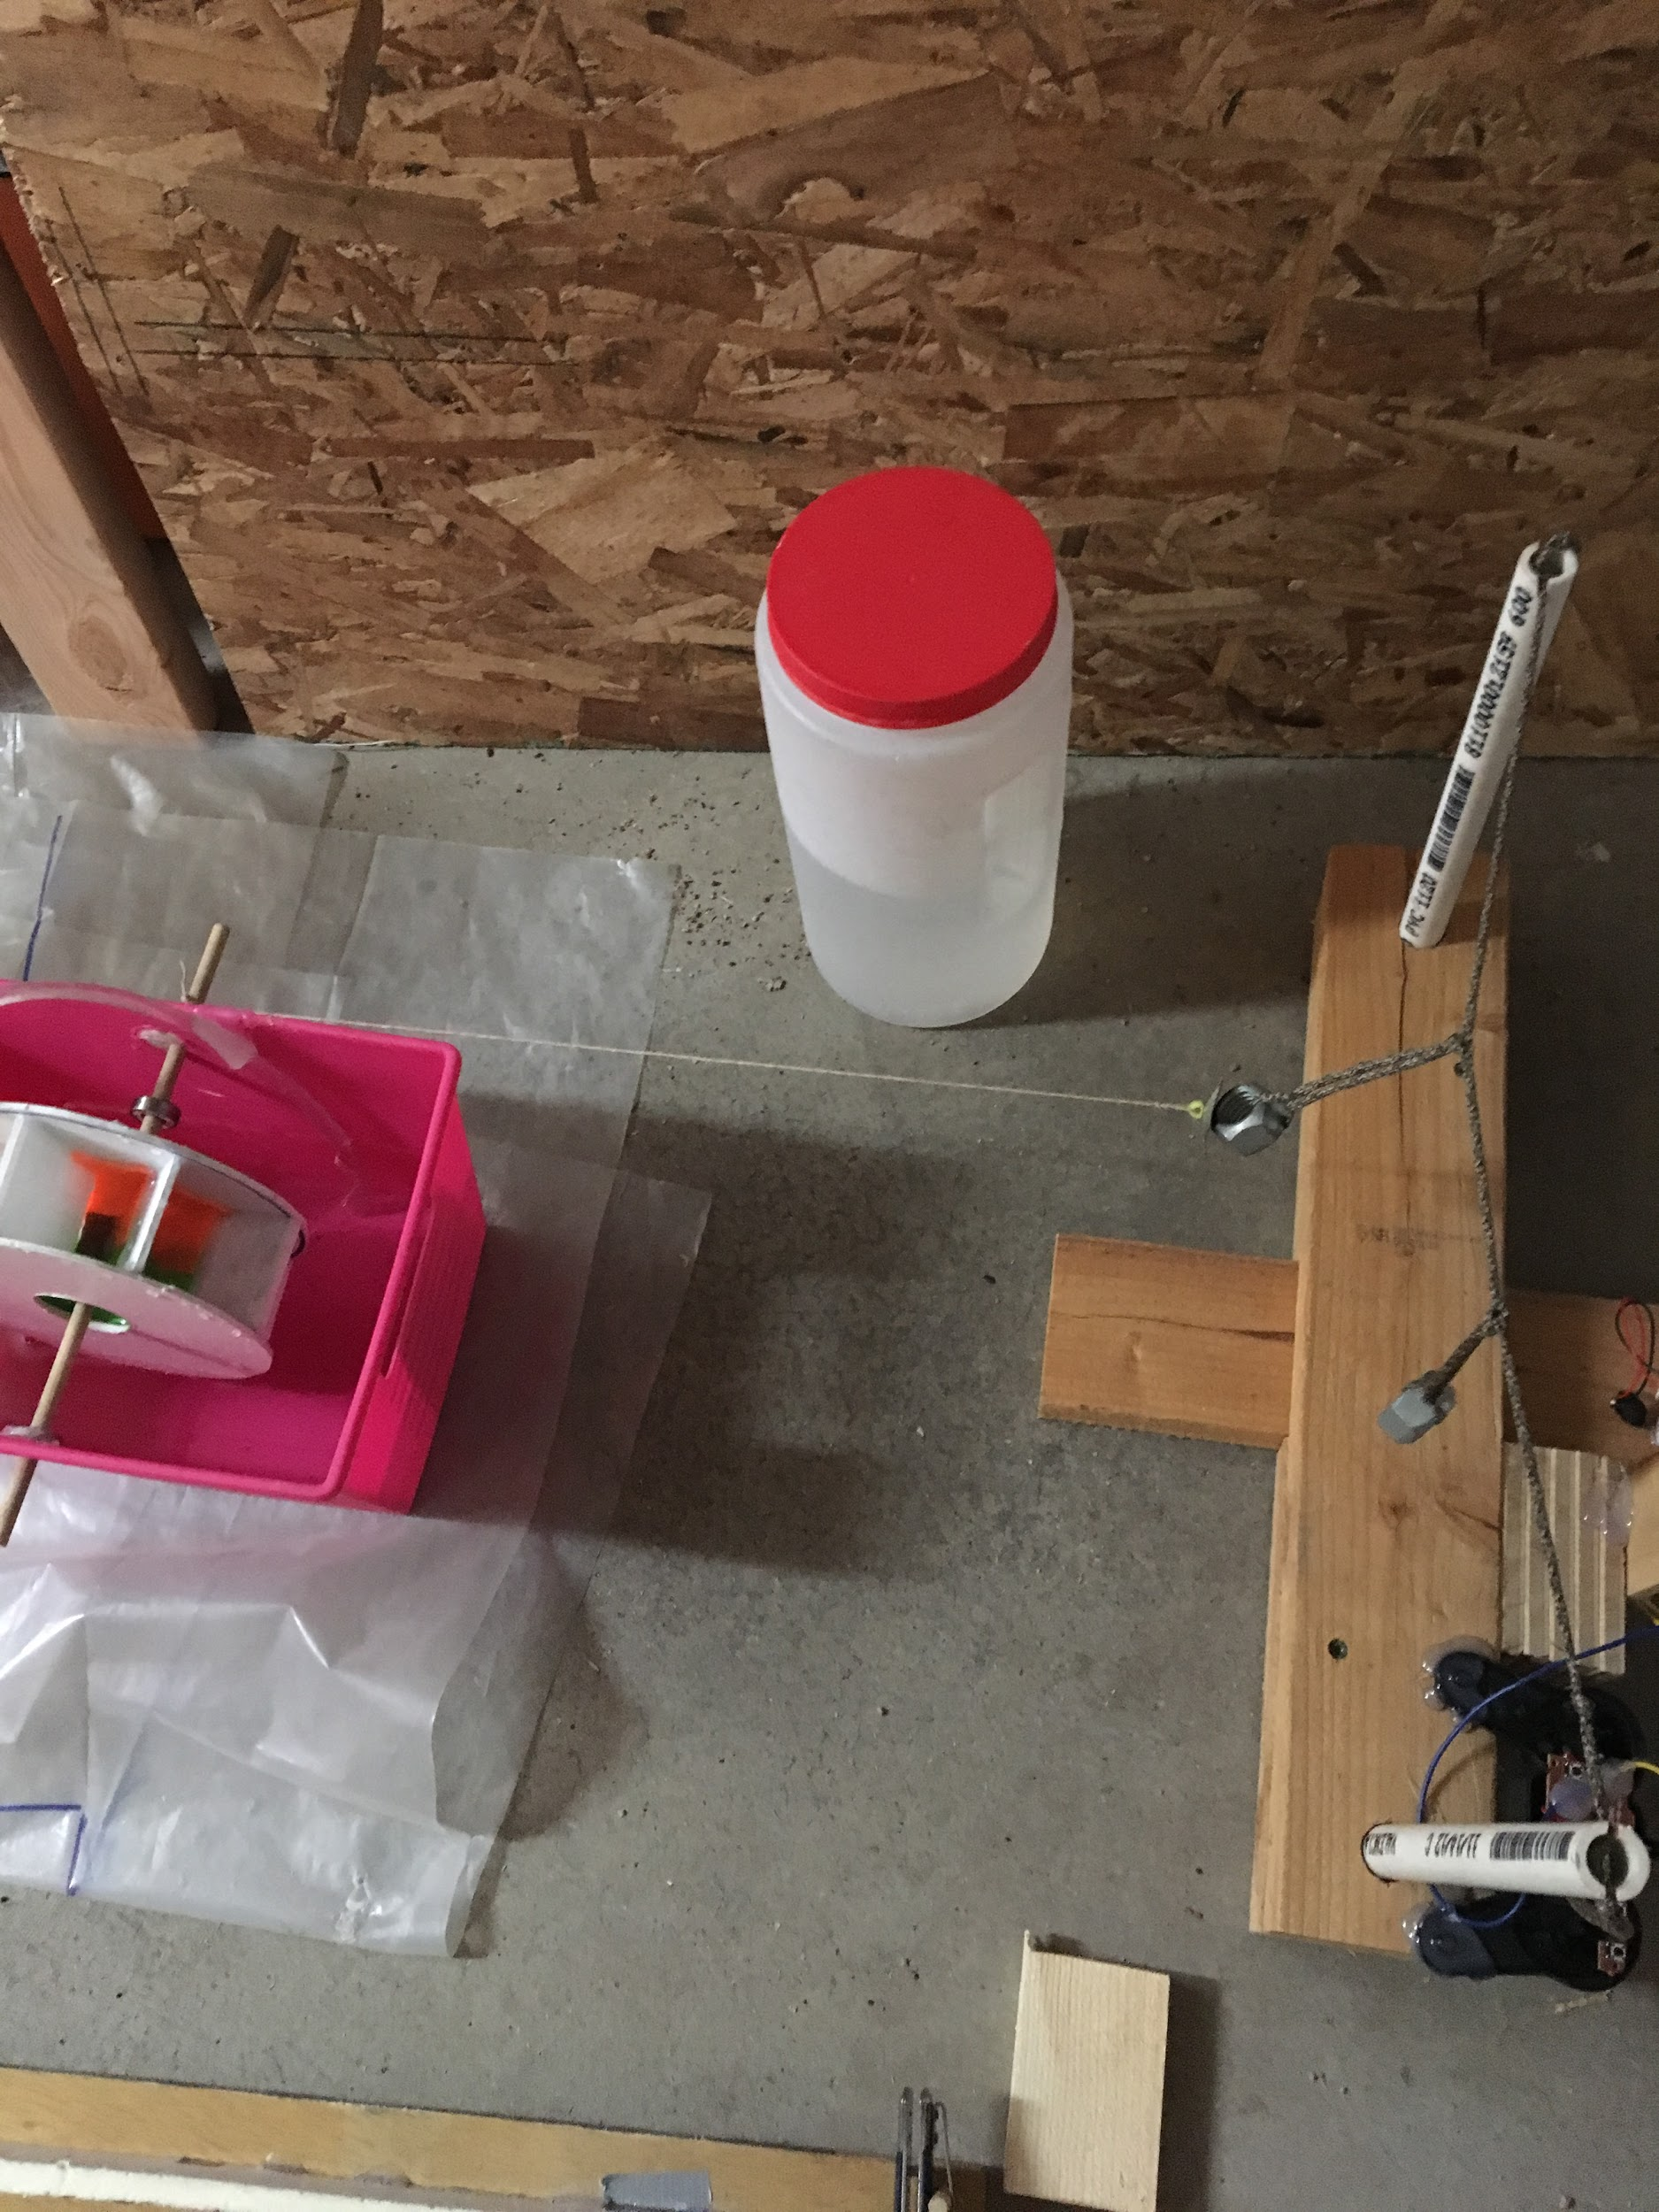
Figure 41: Water Wheel and Dual Pendulum Steps

As the motion of the first pendulum moves to the second, it makes contact with a switch that starts the final steps of the machine. This switch starts the motion of an RC bus that runs along foam board rails. A switchblade toothbrush is placed at the end of these rails, that opens once contact is made by the bus. As the tooth brush open, it flips the ball cannon that shoots a ball bearing down the wooden rail structure. The switch at the end of these steps triggers the toothpaste dispenser, which features a continuous rotation motor that contracts the toothpaste tube. This is shown in figure 42.

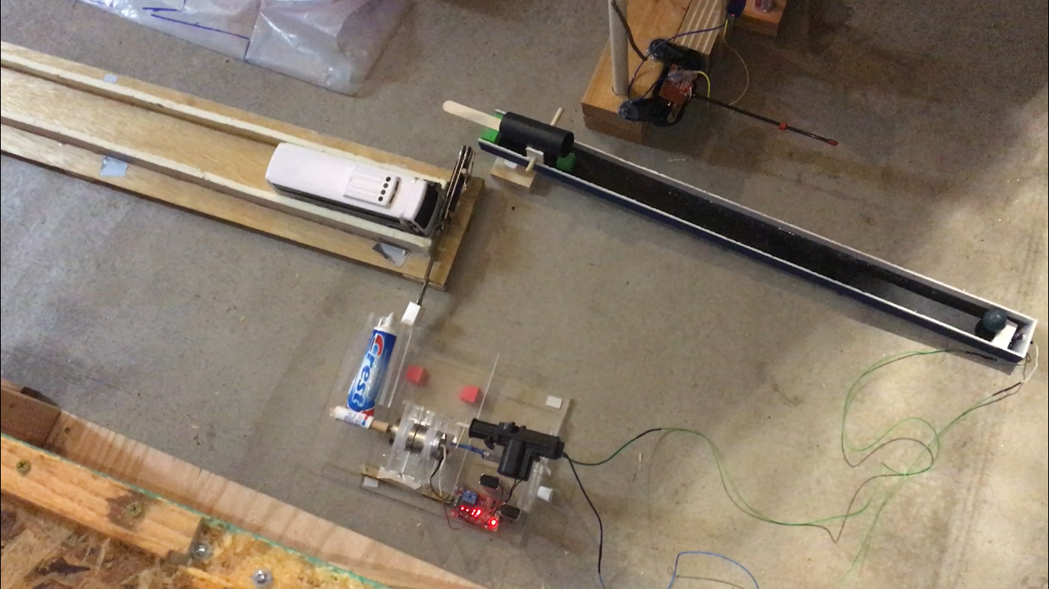
Figure 42: Final Steps Assembly

8 Testing
The qualities from Table 2 such as run time, volume, and automation became the top priority during testing. To test runtime and runtime per step, the steps had to be assembled, set-in place, ran through and timed. The average runtime overall was 1 minute and 7 seconds and the runtime per step ended with an average of 2 seconds per step. Both times fell below the target value set in the engineering requirements. Original target values were 3 minutes total runtime and 5 seconds per step. Automation was tested by repeatedly running through those steps with automation to ensure they worked correctly. These automated steps has a success rate of 85% with some steps never failing while others failed only a few times. This was a clear problem as initially these automated steps worked 100% of the time with our testing phase, when they were transported fragile pieces, like the gears of the servo motors, broke apart and created a spotty failure. Another step that was working 100% of the time suddenly failed after transportation with no foreseeable fix. This step, the scissor lift step, has to be completely retooled to fix this failure. This is in line with our target value of having some automation in the project nicely. To test the volume of our project we measured its footprint in a square along with its highest point. The footprint was 10x10 ft with the highest point being 4 ft tall. With a volume total of 400 ft${}^{3}$. A picture of the full assembly is shown in figure 43.

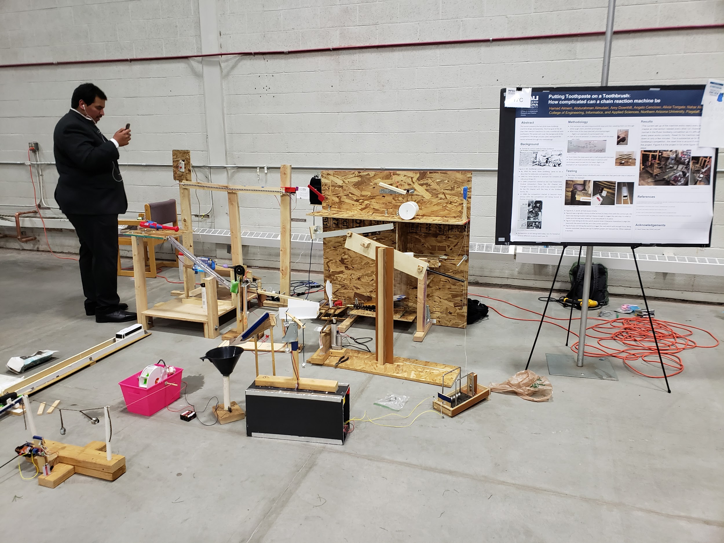
Figure 43: Full Machine Assembly

9 Conclusions

9.1 Contribution to Project Success
Success is something that is hard to define for a chain reaction machine. If it works in any sense that should be considered a success even if it has a few interventions. This project is no exceptions to that rule. This project is definitely considered a success due to the fact the team was able to run it multiple times without it breaking down entirely. Contributing to this success is the project idea itself. A chain reaction machine is a very different kind of engineering project that enabled the team to not be limited by expected constraints that would be normally expected of us in a normal engineering capstone. We instead could focus on the idea of fun and creativity inside of the project. The form of the overall project itself allowed us to easily modify things or change entire sections of the project without worrying how they would change or effect the rest of the project. This ability to completely scrap ideas if they weren’t working successfully or didn’t allow for easy readability in our project saved the group from being hung up on a step. The process of learning a new skill, the coding and wiring needed to operate an arduino, allowed to team to achieve steps that were otherwise going to be incredibly difficult to implement with in a short time frame. Next the ability to essentially form two teams to work on the project also allowed for the team to delegate tasks more efficiently to ensure things could get accomplished in time. This set up proved to be invaluable when it came to the building phase of the section. This was because trying to coordinate six schedules is more difficult than just three.

Our client, Dr. Trevas, helped contribute to the success of this project. He was a wealth of knowledge in several relevant aspects of our project. These being, but not limited to; the history and the feel of a chain reaction machine, coding the arduino, appropriate timing on each step and parts needed to achieve the effect desired. He was specifically able to guide us on what we should achieve to get the feel of a chain reaction machine and Rube Goldberg’s comics without leading to something that would be out of the scope of what could be accomplished in the time frame of this project.

Lastly what really contributed to our project was the ease of purchase for our materials. Compared to other groups, they had to specially order or even machine the parts they needed to ensure they were getting what they needed. This has the ability to go hypothetically go thrifting for parts to get the desired affect wanted. While the team only thrifted a few parts, most of the parts were bought from hardware stores or toy shops. Due to this the team was able to assemble the piece together without the need or cost of waiting on parts.

9.2 Opportunity for Improvement
While the team was able to meet project requirements within our time constraints, there were a number of areas that we could have improved our design and processes. Since the team was focused most heavily on the functionality of the design, aesthetics were not a priority. While the main supports for all of the steps were wood, and many of the plastic components had complimentary colors, we could have worked to make our items look more uniform. One of the most notable takeaways from our competition with the University of Arizona was our lack of theme. While we had more variety with our steps, UA’s team had a more aesthetically pleasing design, since the structure of their steps recreated a realistic bathroom scene. If we had more time, we may have been able to make more uniform aesthetics.

Assembly of our design also had room for improvement. While we made many of our large structure components modular to help reduce the volume, some of our steps were solid structures, which made it harder for transit. Also, the team’s first time completely deconstructing the machine happened right before competition, and we had a number of issues making our steps work correctly once they were reconstructed. If the team had worked with breaking down the design and rebuilding it more, we may have been able to make the machine function properly in a more time efficient manner.

More in depth preparation would have also helped the team for competition. Since the team knew that some of the components were not durable, it would have helped us to have more replacement components on hand at competition. The gears of our servo motor for the bat swing step sheared, and we did not have a replacement at the time. The motor broke again at UGRADS, and while we had a replacement motor, we had to run home to collect it before presenting. We were also not prepared for the wind. While we did not know that we would be presenting outdoors, nor would experience extreme weather conditions for our competition, we should have been more diligent about researching the weather. All of our testing was completed in controlled environments, and it could have helped to do testing outside once determining that the competition was outdoors.

Finally, it would have helped if we had started building during the first semester of the project. While we were able to finish all of our steps, we likely would have been able to find and fix issues that presented themselves during competition and UGRADS. The team was so focused on finishing our deliverables from that semester, that we did not have time to dedicate to full scale building. While this change would have meant spending less time working on those deliverables, which could have caused a drop in quality, it would have allowed us to get further ahead on our building, and would have given us more time to make the machine function reliably at each of our events.
References
[1] J. Frost, OK GO, S. L. , and S. Moyers, “OK Go - This Too Shall Pass - Rube Goldberg Machine - Official Video,” YouTube, 01-Mar-2010. [Online]. Available: https://www.youtube.com/watch?v=qybUFnY7Y8w. [Accessed: 26-Oct-2018].
[2] P. U. M. Engineering, “2018 Rube Goldberg Machine Contest Champions: Purdue PSPE,” YouTube, 23-Apr-2018. [Online]. Available: https://www.youtube.com/watch?v=zPVH2admAuw&t=29s. [Accessed: 26-Oct-2018].
[3] K. Kraemer, “NAU Rube Goldberg Run 1 2018,” YouTube, 20-Apr-2018. [Online]. Available: https://www.youtube.com/watch?v=r-kPux2zU0Y. [Accessed: 26-Oct-2018]
[4] Newton's Cradle. ANALYTICAL SCIENTIFIC, LTD. Available: https://www.analyticalsci.com/store/p118/The_Famous_Newton%27s_Cradle%2C_Mini.html. [Accessed: Oct. 24, 2018].
[5] “coin funnel, hyperbolic funnel, gravity well, wishing well, money well,” coin funnel, hyperbolic funnel, gravity well, wishing well, money well. [Online]. Available: http://hyperbolicfunnel.com/. [Accessed: 27-Oct-2018].
[6] Library Makerlab Staff, personal communication, January 25, 2019.

Appendix A

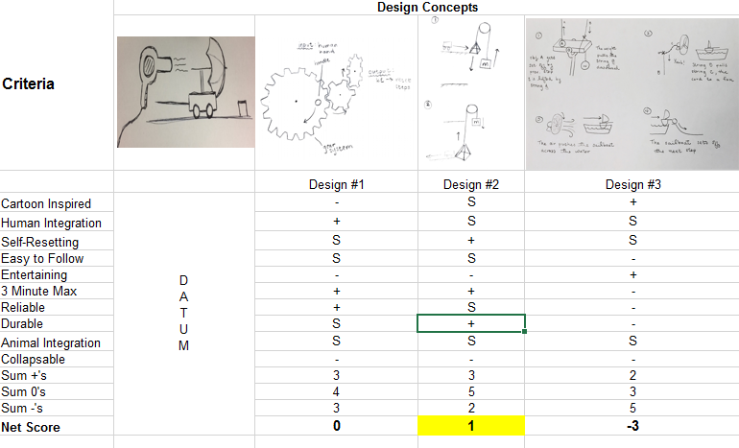
Figure A.1: Pugh Chart
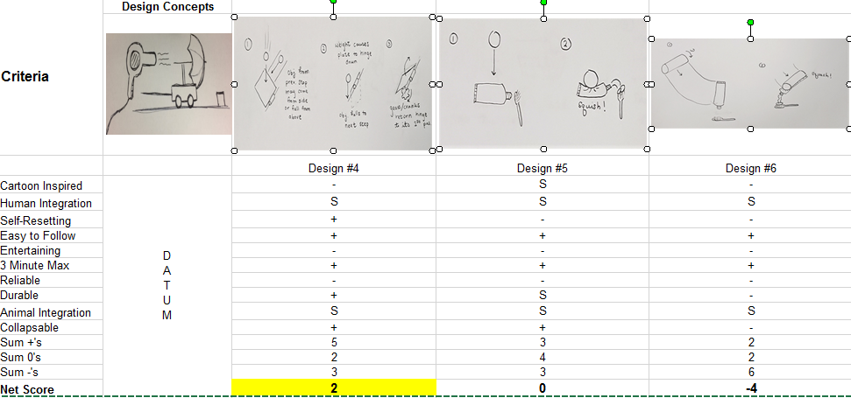
Figure A.2: Pugh Chart

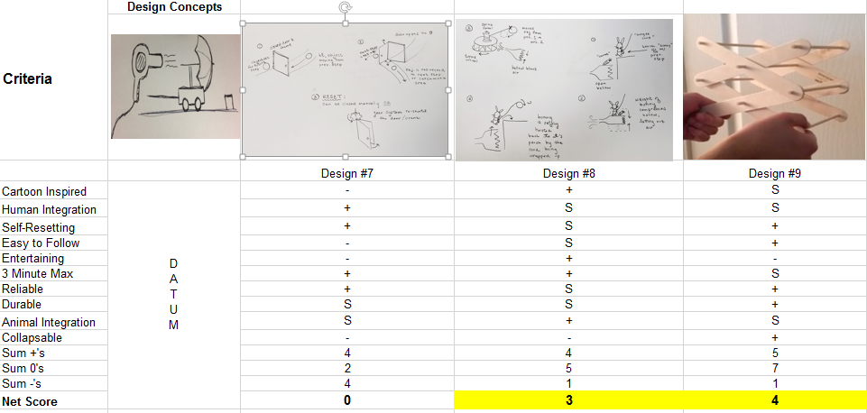
Figure A.3: Pugh Chart
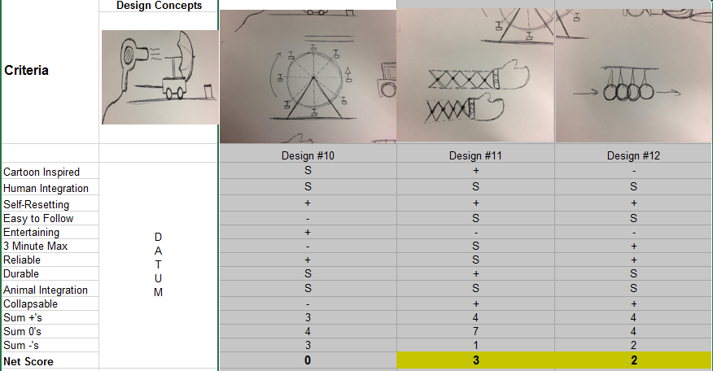
Figure A.4: Pugh Chart

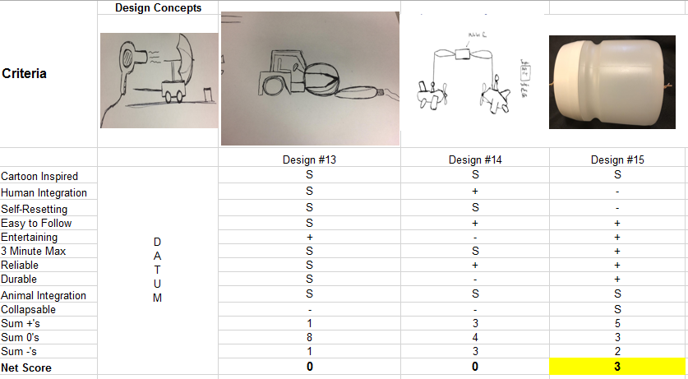
Figure A.5: Pugh Chart

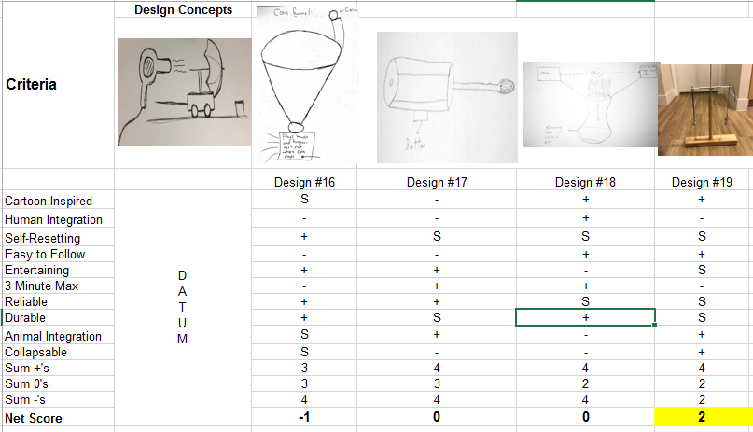
Figure A.6: Pugh Chart

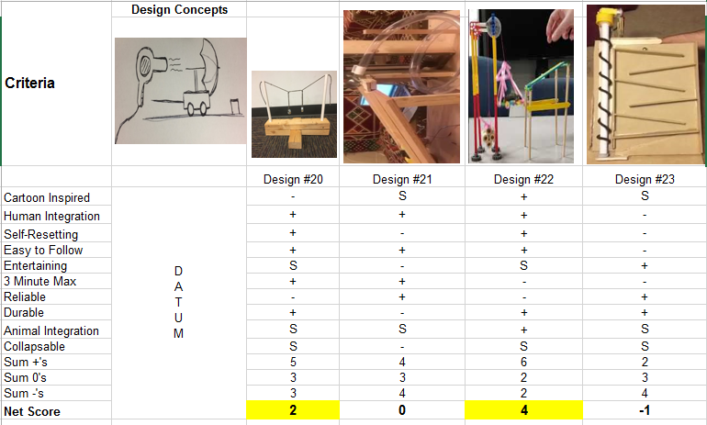

Figure A.7: Pugh Chart

Appendix B
In the decision matrix also the customer requirements are noted at the left and Weight % out of 5 is assigned to all the requirement. The designs shortlisted from the Pugh chart is evaluated in the decision matrix. Score out of 5 is given to all the requirement for each design and multiplied with the weight % to get the weightage score to that respective customer requirement. Weighted score is added for each design to get the net score. The designs which scored higher is selected for developing the prototype. The selected designs are also highlighted in the Table B.1 and Table B.2

Table B.1: Decision Matrix
Criteria | Weight % | Design #2 |  | Design #4 |  | Design #8 |  | Design #9 |  | Design #11
Criteria | Weight % | Score | Weighted Score | Score | Weighted Score | Score | Weighted Score | Score | Weighted Score | Score | Weighted Score
Cartoon Inspired | 2 | 3 | 6 | 1 | 2 | 5 | 10 | 3 | 6 | 4 | 8
Human Integration | 5 | 3 | 15 | 2 | 10 | 3 | 15 | 3 | 15 | 3 | 15
Self-Resetting | 5 | 4 | 20 | 4 | 20 | 3 | 15 | 5 | 25 | 5 | 25
Easy to Follow | 4 | 3 | 12 | 5 | 20 | 3 | 12 | 5 | 20 | 2 | 8
Entertaining | 4 | 0 | 0 | 0 | 0 | 4 | 16 | 1 | 4 | 0 | 0
3 Minute Max | 5 | 4 | 20 | 5 | 25 | 4 | 20 | 3 | 15 | 3 | 15
Reliable | 5 | 3 | 15 | 1 | 5 | 3 | 15 | 4 | 20 | 3 | 15
Durable | 3 | 4 | 12 | 4 | 12 | 3 | 9 | 5 | 15 | 4 | 12
Animal Integration | 2 | 3 | 6 | 2 | 4 | 4 | 8 | 3 | 6 | 3 | 6
Collapsable | 4 | 1 | 4 | 5 | 20 | 1 | 4 | 4 | 16 | 5 | 20
Net Score |  |  | 110 |  | 118 |  | 124 |  | 142 |  | 124

Table B.2: Decision Matrix
Criteria | Weight % | Design #12 |  | Design #15 |  | Design #19 |  | Design #20 |  | Design #22
Criteria | Weight % | Score | Weighted Score | Score | Weighted Score | Score | Weighted Score | Score | Weighted Score | Score | Weighted Score
Cartoon Inspired | 2 | 1 | 2 | 3 | 6 | 5 | 10 | 1 | 2 | 4 | 8
Human Integration | 5 | 3 | 15 | 1 | 5 | 0 | 0 | 5 | 25 | 5 | 25
Self-Resetting | 5 | 3 | 15 | 1 | 5 | 3 | 15 | 4 | 20 | 4 | 20
Easy to Follow | 4 | 4 | 16 | 4 | 16 | 5 | 20 | 5 | 20 | 4 | 16
Entertaining | 4 | 0 | 0 | 5 | 20 | 3 | 12 | 3 | 12 | 3 | 12
3 Minute Max | 5 | 4 | 20 | 5 | 25 | 2 | 10 | 5 | 25 | 1 | 5
Reliable | 5 | 5 | 25 | 4 | 20 | 4 | 20 | 1 | 5 | 2 | 10
Durable | 3 | 2 | 6 | 5 | 15 | 2 | 6 | 4 | 12 | 5 | 15
Animal Integration | 2 | 2 | 4 | 3 | 6 | 4 | 8 | 3 | 6 | 4 | 8
Collapsable | 4 | 4 | 16 | 3 | 12 | 5 | 20 | 2 | 8 | 2 | 8
Net Score |  |  | 119 |  | 130 |  | 121 |  | 135 |  | 127

Appendix C

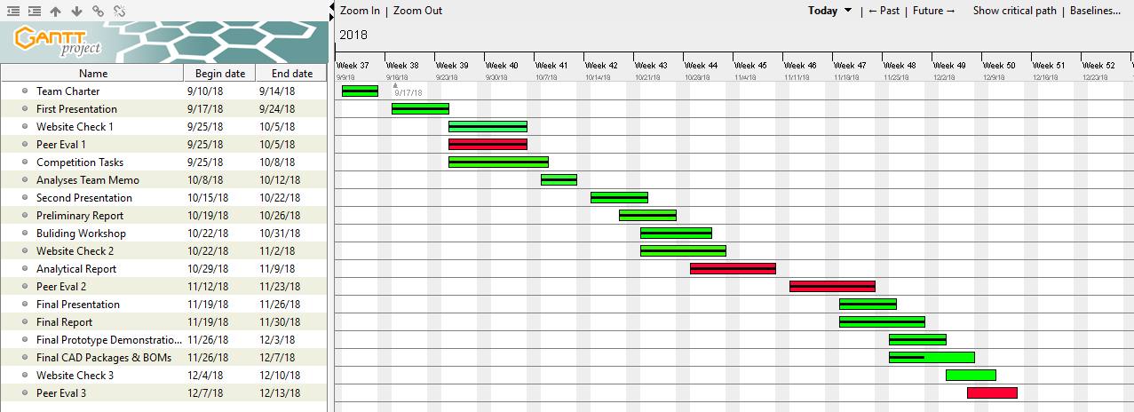
Figure C.1: Fall 2018 Gantt Chart

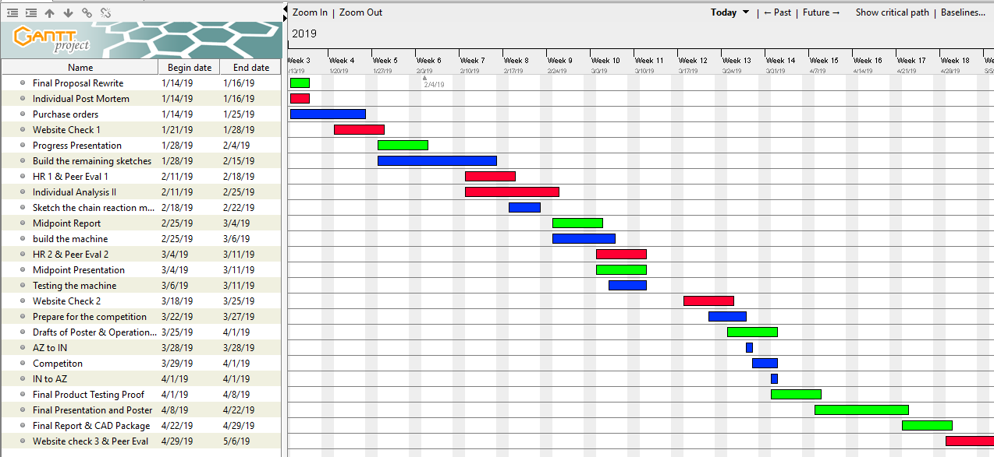
Figure C.2: Spring 2019 Gantt Chart

Appendix D
Table D.1: Bill of Materials for Assembly

Manufacturer | Part Number | Part Name | Quantity | Unit of Measure | Cost/Unit | Notes
Everbilt | D68820E-W-W | 20 in. Self-Closing Bottom Mount Drawer Slide Set | 1 | 20 in. rail length | $7.48 | Purchased at Home Depot
Grip-Rite | 158GCS1 | 1-5/8 in. Construction Screw | 182 total, 85 used | Size #6, 1-⅝ in. length | $8.47 | Purchased at Homco
Everbilt | 18564 | 1-1/2 in. Zinc-Plated Corner Brace | 20 total, 15 used | Width of 0.5 in. height of 1.5 in. depth of 0.06 in. | $8.98 | Purchased at Home Depot
Everbilt | 14814 | 6 in. x 8 in. Shelf Bracket | 4 | 6 in. by 8 in. | $1.48 | Purchased at Homco
Dimensions Plywood | 225448 | Orient Strand Board (OSB) | 4 | 2 ft. by 4 ft. by 7/16 in. | $16.74 | Purchased at Home Depot
Everbilt | 802237 | 3/8 in. x 36 in. Zinc Threaded Rod | 4 | ⅜ in. diameter, 36 in. length | $2.87 | Purchased at Home Depot
**Mendocino Forest Products | 02463 | 2 in. x 4 in. x 8 ft. Construction Common S4S Redwood Lumber | 3 | 2 in. by 4 in. by 8 ft. | $5.00 | Purchased at Home Depot, defective shape
Everbilt | 803294 | Zinc-Plated Nuts and Washer Kit | 1 |  | $3.98 | Purchased at Home Depot
 |  | 2 in. Construction Screw | 32 | Size #8, 2 in. length | $0.00 | Screws previously owned
 |  | Black 12 in. zip-tie | 6 | 1 ft. length | $0.00 | Zip ties previously owned
 |  | Plastic Protein Powder Jar | 1 |  | $0.00 | Jar recycled
 |  | Rubber bands | 3 |  | $0.00 | Rubber bands previously owned
 |  | Twine | 1 | 100 ft. spindle | $0.00 | Twine previously owned
 |  | Extension Brackets | 2 | Size #10 diameter holes | $0.00 | Brackets previously owned
 |  | Machine Screws | 20 | Size #10, 1 in. length | $0.00 | Screws previously owned
Amagabeli Garden and Home | B07GP5YZKG | Fireplace Bellows19"x 8" Large Wood | 1 | 19 in. by 8 in. by 1.6 in. | $29.99 | Purchased on Amazon
Elegoo | EL-CB-001 | Elegoo EL-CB-001 UNO R3 Board ATmega328P ATMEGA16U2 with USB Cable for Arduino | 4 | ATmega328P microcontroller, Input voltage - 7-12V, 5V Electric current: 500MA, 3.3V Electric current: 50MA, 14 Digital I/O Pins (6 PWM outputs), 8 Analog Inputs * 32k Flash Memory, 16Mhz Clock Speed | $11.86 | Purchased on Amazon
Chinly | SR5332 | CHINLY 3.3ft 60leds WS2812B Individually Addressable LED Strip Light 5050 RGB SMD 60 Pixels Dream Color Waterproof IP67 Black PCB 5V DC (Black PCB 3.3ft 60leds waterproof) | 1 | 3.3 ft long, 60 LEDs | $9.99 | Purchased on Amazon
 |  | Continuous rotation servo | 1 | 360 degree rotation, Torque: 5.5kg/cm (at 4.8V)  Speed: 0.22sec/60°(at 4.8V)  Working voltage: 4.8v-6v DC | $0.00 | Gifted from Tanner Lehr
 |  | 3D-Printed Servo Casing | 1 |  | $0.00 | Gifted from Tanner Lehr
 |  | Graduation announcement paper | 1 | 1.5’’x3’’ | $0.00 | Paper previously owned
 |  | Binder clip | 1 |  | $0.00 | Binder clip previously owned
Edgelec | B07GD2BWPY | EDGELEC 120pcs Breadboard Jumper Wires 10cm 15cm 20cm 30cm 40cm 50cm 100cm Optional Arduino Wire Dupont Cable Assorted Kit Male to Female Male to Male Female to Female Multicolored Ribbon Cables | 1 | 10cm, 15cm, 20cm, 30cm, 40cm, 50cm, 100cm lengths | $5.79 | Purchased on Amazon
REXQualis | RQ-BK-002 | 4PCS Breadboards Kit Include 2PCS 830 Point 2PCS 400 Point Solderless Breadboards for Arduino Proto Shield Distribution Connecting Blocks | 1 | 830 points, 400 points | $9.99 | Purchased on Amazon
Gikfun | LYSB01E38OS7K | Gikfun 12x12x7.3 mm Tact Tactile Push Button Momentary SMD PCB Switch with Cap for Arduino (Pack of 25pcs) AE1027 | 1 | 12x12x7.3 mm | $7.68 | Purchased on Amazon
Douglas-fir | 441317 | 2 in. x 4 in. x 4 ft. Premium Standard and Better Douglas Fir Lumber | 3 | 2 in. x 4 in. x 4 ft | $3.12 | Purchased at Home Depot
Gibraltar Mailboxes | E1100B00 | Elite Medium Black Galvanized Steel Post-Mount Mailbox | 1 | 20 in length | $19.48 | Purchased at Home Depot
Keywish | HC-SR04 | Keywish 5PCS HC-SR04 Ultrasonic Module Kit Distance Sensor for Arduino UNO Mega R3 Mega2560 Nano Duemilanove Nano Raspberry Pi 3 Robot | 1 | 2cm to 450 cm pings | $9.49 | Purchased on Amazon
Kookye | 2xDS04 360 | KOOKYE 2PCS Mini Servo Motor 360 Degree Continuous Rotation w/Servo Horn Set | 1 | 360 degree rotation, Torque: 5.5kg/cm (at 4.8V)  Speed: 0.22sec/60°(at 4.8V)  Working voltage: 4.8v-6v DC | $15.99 | Purchased on Amazon
American Robotic Supply | B01CX63AOQ | TowerPro SG92R Micro Servo - 2 pack | 2 |  | $14.95 | Purchased on Amazon
 |  | Bailing Wire | 1 | 100 ft length | $0.00 | Bailing wire previously owned
UDP | T10007004 | 3/16 in. I.D. x 5/16 in. O.D. x 20 ft. Clear Vinyl Tubing | 1 | 5/16 in, 20 ft. length | $4.93 | Purchased at Home Depot
BC Precision | 578993211005 | 500 Piece Assorted Loose Bicycle Bearing Balls 1/8", 5/32", 3/16" 7/32" & 1/4" | 1 | 1/8", 5/32", 3/16" 7/32" & 1/4" | $7.45 | Purchased on Amazon
Lego |  | Lego Box Set | 1 |  | $14.99 | Purchased at Walmart
 |  | USB Hub | 1 | 4 Ports | $0.00 | Hub previously owned
 |  | USB Cables | 4 | 20 ft. length | $0.00 | USB cables previously owned
 |  | Power Strip | 1 | 8 ports | $0.00 | Power strip previously owned
Home Depot | Model # 70077 | Twine Rope | 1 | #12 x 420 ft. | $2.98 | Purchased at Home Depot
 | Model # HDDH1248 | Wood Round Dowel | 1 | 1/2 in. x 48 in. | $1.85 | Purchased at Home Depot
AdTech | 567127197 | Hot glue | 1 | 30 4 in. sticks | $3.97 | Purchased at Walmart
Elmer’s | 571226876 | Wood glue | 1 | 4 Fl. Oz. | $3.27 | Purchased at Walmart
Duracell | 551417708 | Alkaline batteries (9V) 4 count | 4 |  | $8.00 | Purchased at Walmart
Duracell | 556358252 | AA batteries 24 count | 1 | AA | $16.24 | Purchased at Walmart
Hot Wheels | 561087081 | Toy car | 1 | 1:64 scale | $2.09 | Purchased at Walmart
SATINIOR | Chuangchou--COIN RING-01 | 8 Stainless Steel balls | 1 | Assortment of 3/ 4 Inch, 5/ 8 Inch, 9/ 16 Inch, 1/ 2 Inch, 7/ 16 Inch, 3/ 8 Inch, 5/ 16 Inch and 1/ 4 Inch | $7.25 | Purchased at Amazon
Elmer’s | 551627088 | Foam Display Board | 1 | 28x40 Inch | $7.97 | Purchased from Walmart
 |  | Wooden mount | 1 |  | $0.00 | Previously Owned
 |  | Wooden frame | 1 |  | $0.00 | Previously Owned
UCTRONICS | B07BT32T1M | DC 12V Programmable Multifunction Time Delay Relay Module with Segment LEDs Display & H/L Level Trigger for Smart Home, Automatic Control | 3 | 3.4 x 2.5 x 0.9 inches | $13.00 | Purchased at Amazon
XCH Robots | B07DZG8T76 | Newton’s cradle | 1 | Dimensions: 7.1 x 4.7 x 7.1 inches | $11.99 | Purchased at Amazon
Uxcell | a18051700ux0440 | DC Motor Electric Gear Box Gearbox 6V 133RPM | 1 | Body Size : 29 x 38mm / 1.1" x 1.5" (D*H);Shaft Dia. : 2.3mm/ 0.09";Total Length : 58mm / 2.3" | $15.00 | Purchased at Amazon
Lumax | LX-1604 | Funnel | 1 | 48 oz., Opening diameter: 8 in., Length of spout: 2-1/4 in., Overall height: 7 in., Spout opening: 3/4 in. | $5.35 | Purchased at Home Depot
 |  | Quarter dollar | 2 |  | $0.25
Gardner Bender | Model # GSW-21 | Switch Buttons | 5 |  | $4.98 | Purchased at Home Depot
 |  | Ball Carrier | 1 |  | $0.95 | Purchased and Repurposed from Home Depot
 |  | Small Light Up Ball | 1 |  | $3.00 | Purchased at Big five
Progressive Automations | PA-14-2-35 | Linear Actuator | 1 | Stroke Size 2", Force 35 lbs, Speed 2.00"/sec | $111.99 | Purchased on Amazon
Uxcell | a17082900ux0296 | Small Motor DC 24V | 1 | Dimension: 38mm x 29mm | $7.25 | Purchased on Amazon
 |  | Wooden Rack | 1 |  | $2.30 | Purchased at Goodwill
Colgate |  | Toothpaste | 1 |  | $0.00 | Previously Owned
 |  | Toothbrush | 1 |  | $0.00 | Previously Owned
 |  | Black box | 1 |  | $0.00 | Previously Owned
 |  | Knife | 1 |  | $0.00 | Previously Owned
 |  | Track Toy | 1 |  | $0.00 | Previously Owned

